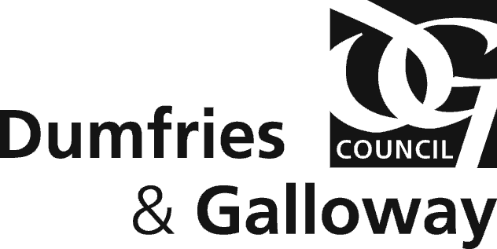

HYPNOTISM ACT 1952

APPLICATION TO GIVE AN EXHIBITION, DEMONSTRATION OR
PERFORMANCE OF HYPNOTISM

Note: Each of these questions must be answered. It is a criminal offence to make any statement which you know to be false or recklessly to make any statement which is materially false.

- Full Name
- Stage Name (if different)

- Home Address
- Email Address

- Phone No. | Daytime:  Mobile:
- Date of Birth

- Place of Birth

- Location of the proposed performance(s)
- Date(s) of the proposed performance(s)
- Hours of the proposed performance(s)

- Are you a Member of Federation Ethical Stage Hypnotists or any other professional body or trade association related to Hypnotism?

Yes/No

If yes, please provide details

- Have you ever been refused or had your membership revoked from any such association?

Yes/No

If yes, please provide details

- Have you ever been refused or had any consent withdrawn by a Licensing Authority?

Yes/No

If Yes, please provide details

- Please provide a description of the proposed exhibition, demonstration or performance (enclose copies of posters, advertisements or programme if applicable):

- If the performance includes hypnotising members of the public, will minders stay with hypnotised subjects during the show including the interval?

Yes/No

- Is the hypnotist providing a minder for each hypnotised subject?

Yes/No

If no, how many hypnotised subjects will a minder supervise?

- Have you ever been convicted of an offence under the Hypnotism Act 1952 or of an offence involving the breach of a condition regulating or prohibiting the giving of an exhibition, demonstration or performance of hypnotism on any person at any location?

Yes/No

If yes, please provide details

I declare that I have checked the information given on this application form and to the best of my knowledge and belief it is correct. I have enclosed a cheque for £99 in payment of fee.

I confirm that I have read and understand the Council’s standard conditions relating to the regulation of exhibitions, demonstrations or performances of hypnotism (copy attached) and undertake to comply with such conditions at all times. I am aware that exhibitions, demonstrations or performances of hypnotism are not permitted unless the Licensing Authority has issued a valid permit.

I declare that I have obtained permission from the relevant premises owner and have provided a telephone number on which I can be contacted for up to 12 hours after any performance. I understand that any consent issued will be for dates and times as agreed only.

I understand that applications should be made no later than 28 days prior to any performance and failure to comply may mean the application will not be determined in time for the performance.

Signature ……………………………………………………………

Date ……………………………………………………………

Please complete all sections of the application form, as incomplete applications will be returned to the applicant.

Please note that occasionally additional information may be required in order to process the application.

Licensing, Dumfries and Galloway Council,
Kirkbank House, English Street, Dumfries, DG1 2HS
 01387 245922

together with the following:

£99 application fee

Copy of public liability insurance (min cover £5million)

Copies of posters, advertisements or programme

