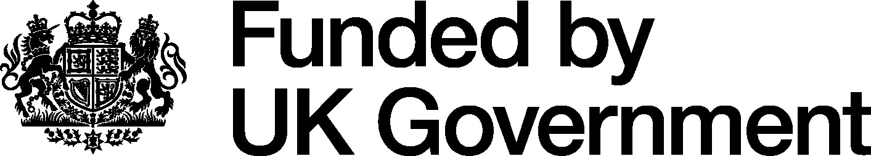

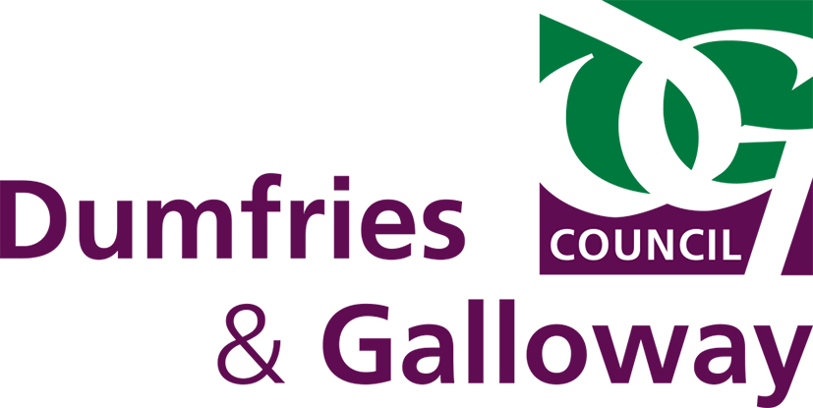

Applications to open for Regional Cultural Fund to boost Culture, Heritage and Tourism in the Region

Date of Issue: Wednesday 12 June 2024
(Embargoed until Thursday 13 June)

Dumfries and Galloway Council has announced a new funding programme for the cultural and heritage sectors of the region.

The Regional Cultural Fund has been introduced to make grants of up to £5000 available to enhance, improve and promote community-led creative and cultural programmes and facilities in Dumfries and Galloway. The Fund provides the opportunity for arts, heritage and community organisations across the region to take forward work that they could not otherwise finance.

The application process is open from Monday 17 June until Friday 26 July.

The programme is being taken forward in partnership with South of Scotland Enterprise, Dumfries and Galloway Unlimited and the
Dumfries and Galloway Museums and Heritage Network.

The grant programme has been made possible through the Council securing £96,000 of funding from the UK Government’s Shared Prosperity Fund earlier this year. Harry Hay, Head of Thriving Communities at Dumfries and Galloway Council said, “This new Fund can enable many cultural and heritage organisations, agencies and visitor attractions in the region to generate additional investment in their work and activities. From the Mull of Galloway to Moffat, Kirkcudbright to Kirkconnel, most communities across Dumfries and Galloway have local organisations that are dedicated to cultural, heritage or tourism development and I’m confident there will be a brilliant response to the Fund.”

Frank Hayes, the Chair of Dumfries and Galloway Unlimited said, "The UK government's Shared Property Fund is an important additional resource which will provide much needed financial support to heritage and cultural projects in Dumfries and Galloway. DG Unlimited is proud to be working with Dumfries and Galloway Council and colleagues from the Cultural and Heritage sectors."

Mark Geddes, Strategy Manager for Cultural and Creative Capital from South of Scotland Enterprise (SOSE) said: “The significance of our region’s Creative Economy cannot be underestimated, worth an estimated £280 million to the South of Scotland. Working in partnership we are driving forward our work to support, develop and expand hugely our valuable creative ecosystem and this fund is yet another example of that. This is a brilliant opportunity to continue the great work already underway across the region, and I would encourage organisations to apply.”

Judith Hewitt, Chair of D&G Museums and Heritage Network said, “We are pleased that this new Fund has been developed and are excited to see what work it supports within our wonderful museums and heritage organisations.”

DG Unlimited is running a series of workshops on the 24th and 25th June via Zoom or Microsoft Teams. If you would like to attend one of these workshops please register your interest by emailing DG Unlimited at comms.dgu@gmail.com.

Notes for Editors

The Regional Cultural Fund is fully funded by the UK Government through the UK Shared Prosperity Fund. Dumfries and Galloway Council will manage all aspects of the Fund with assistance from DGU – Dumfries and Galloway Unlimited

Full details of the Fund and the application form are available online at;

Funding for arts projects - Dumfries and Galloway Council (dumgal.gov.uk)

“The UK Shared Prosperity Fund is a central pillar of the UK government’s Levelling Up agenda and provides £2.6 billion of funding for local investment by March 2025. The Fund aims to improve pride in place and increase life chances across the UK investing in communities and place, supporting local business, and people and skills. For more information, visit https://www.gov.uk/government/publications/uk-shared-prosperity-fund-prospectus”

