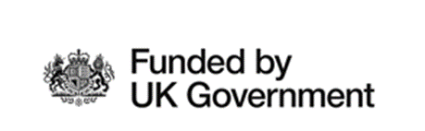

Subsidy Control – Minimum Financial Assistance (MFA)

The Regional Cultural Fund being applied for by your agency or organisation is classified as a Minimum Financial Assistance (MFA) subsidy under the Subsidy Control Act (2022).
To be eligible for the support, you must not have already exceeded receipt of £315,000 in MFA subsidies over this and the previous two financial years.
Note: Minimal Financial Assistance (MFA) is a relatively new term which you may have previously seen referred to as “De Minimis” or “Special Drawing Rights” SDR
Before making any payment, written confirmation that receipt of the payment will not exceed this is required.
This means you must confirm you have not received more than £315,000 minus the value of this subsidy in MFA subsidies or comparable types of subsidy (see section 42(8) of the Subsidy Control Act (2022)) between 1 April 2020 and this date.
We take this opportunity to remind that you are required to keep a written record of the amount of MFA you have received and the date/s when it was received. The written record must be kept for at least three years beginning with the date on which the MFA was given. This will enable you to respond to future requests from public authorities on how much MFA you have received and whether you have reached the cumulative threshold.
Once you have received any grant support from the Regional Cultural Fund, we will issue you with a letter which you can use as your written confirmation.
We, the business do solemnly and sincerely declare that we have made a full enquiry into our affairs, and that, having done so, we and all other entities which form part of the
‘single undertaking’ of which we are a part, confirm that we have received the following public sector support during the previous 2 fiscal years and the current fiscal year.

Value of MFA awarded | Total £
MFA awarded by public bodies over current and two previous fiscal years (including comparable types of subsidies such as De Minimis) | £0
Remaining MFA available | £315,000

Client’s signature
Business Name
