Education, Skills and Community Wellbeing Directorate

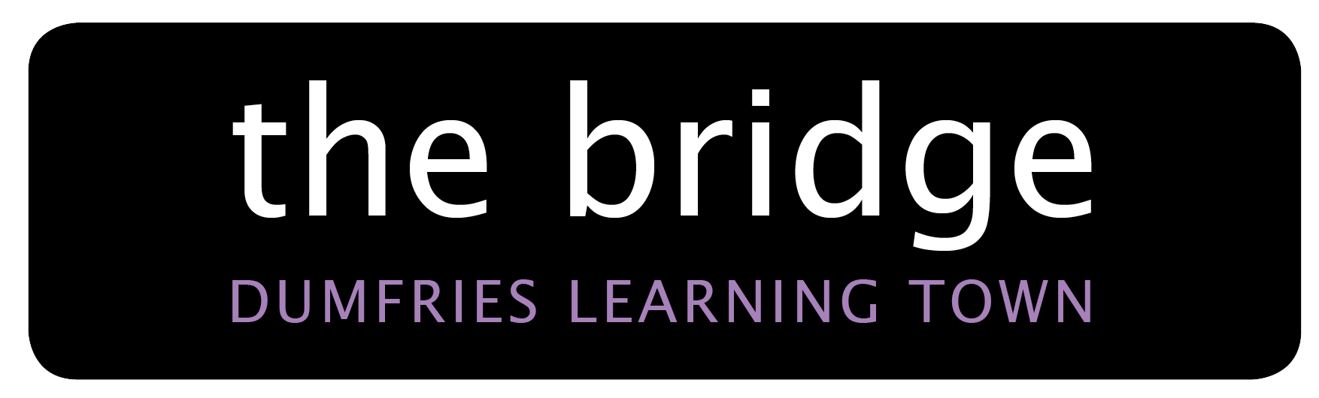

Scale of Charges for Room Bookings
2024 / 2025
(wef 01 04 2024)

Room | Fees
Small Room | Junior (U18) / Senior (60+) - £6.60 per hour  Community Groups - £8.75 per hour  Commercial - £17.05 per hour
Classroom / Large Room | Junior (U18) / Senior (60+) - £10.00 per hour  Community Groups - £13.10 per hour  Commercial - £25.80 per hour
G59 Forum | Junior (U18) / Senior (60+) - £13.45 per hour  Community Groups - £17.85 per hour  Commercial - £35.40 per hour
Large Room / Box Open Area  (G60) | Junior - £10.00 per hour  Adult - £13.10 per hour  Commercial - £25.80 per hour
Dance Studio | Junior - £22.15  Adult - £42.35  Commercial - £62.45
Drama Changing Room | Junior (U18) / Senior (60+) - £6.60 per hour  Community Groups - £8.75 per hour  Commercial - £17.05 per hour
Professional Kitchen | £15.50 per hour  (An additional charge may apply to evenings and weekends)

