**Skills, Education and Learning Directorate**

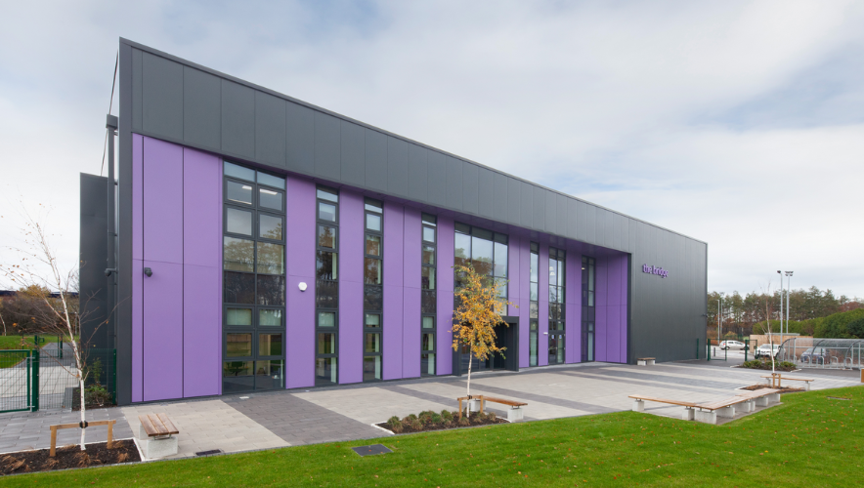

**Procedures and Guidance for**

**Bridge Room Hire**

**August 2023**

1 INTRODUCTION

The Bridge is a common good building, and its purpose must meet the criteria of the common good which is to enhance employment and education for young people.

The Bridge is a facility in Dumfries created to help learners develop specialist skills and knowledge that they need for further education and work.

The Bridge delivers learning opportunities for the whole community with the facility open and available to individuals, community groups, clubs and local organisations. The facility is also available for hire and is an ideal venue for conferences, seminars/demonstration of skills, performances, and other events.

The Bridge is located next to King George V Sport Complex on Glasgow Road, Dumfries and became fully operational in June 2019.

2 APPLICATION GUIDANCE

All let applications for room bookings at The Bridge should be made direct to The Bridge by emailing [thebridge@dumgal.golv.uk](mailto:thebridge@dumgal.golv.uk), or sending to Bridge Room Bookings, The Bridge, Glasgow Road, Dumfries DG2 9AW. Room bookings will be will granted as a matter of course with a case being made to support a decision not to grant access.

Further information and booking forms can be found on Dumfries and Galloway Council’s website at <https://www.dumgal.gov.uk/article/16455/The-Bridge> .

The following should be considered:

* The Bridge is a very popular facility, therefore please ensure that as much notice as possible is given when making a room booking.
* Similarly, if you find that you no longer require the room booking, please give as much notice as possible when cancelling, either by emailing [thebridge@dumgal.gov.uk](mailto:thebridge@dumgal.gov.uk) or by telephoning 40170 / 01387 255660.
* Schools are encouraged to make use of specialist accommodation / equipment available at the Bridge during the school day and for extra curricular activities.
* Schools are also encouraged to make use of the facilities for events out with the school day, however, charges may be applicable if there is an exchange of money at the event.
* Core hours can be booked free of charge by Dumfries and Galloway Council Directorates / Sections. However, charges may be applicable if there is an exchange of money at the event. All internal room booking forms should be made by email to [thebridge@dumgal.gov.uk](mailto:thebridge@dumgal.gov.uk) providing the required information, along with an internal recharge code where required.
* Accommodation is available for let by internal/external clubs/organisations from 16:00 each evening and weekends at the discretion of the School Managers - People, Education and Learning Directorate, provided adequate staff cover is available.
* Cleaning as a result of lets should be kept to a minimum.
* New lets must be recorded on a let application room booking form to confirm acceptance of terms and conditions and charges that will apply on the date of the let.
* Existing users can add to / amend bookings verbally or by e-mail within the confines of the start and end dates requested. A new application form must be completed on an annual basis in April or after the end date of a previous Let application.

3 FACILITIES

Please note the following:-

* There are no tea / coffee / refreshment making facilities at The Bridge. There are two vending machines, one of drinks and one for snacks, available in the Bridge Foyer.
* **Hospitality and catering** **for Internal Departments / Directorates only** can be booked through Dumfries and Galloway Council - [NaturallyDGFunctionCatering@dumgal.gov.uk](mailto:NaturallyDGFunctionCatering@dumgal.gov.uk)
* **Hospitality and catering for Outside Organisations** can be booked at the choice of the hirer.
* The Bridge operates BYOD (Bring Your Own Device) policy for access to the internet. There is no password required to access BYOD.
* Teaching / training / meeting spaces within The Bridge have either short throw projectors and writing walls or 65” Promethean Touch Screen Displays. You will need to provide your own laptop which should have an HDMI connection (if sound is required) or a VGA connection (no sound).
* Dumfries and Galloway Council employees will be automatically connected to Corporate wi-fi throughout the building using Corporate Council devices.
* Car parking at The Bridge is limited to 45 spaces, however there is free alternative parking nearby in the retail park opposite the building.
* The Bridge is situated on Dumfries’ network of walking, cycling and bus routes and has been built and designed with the Region’s travel strategy aims and objectives in mind. Staff, pupils, delegates, and members of the public are asked to use alternative methods of getting to the building.

4 CONDITIONS OF USE

The conditions of let are not a legally binding document. They intend to form the basis of a good working relationship and may form the basis of dispute resolution between the Council and those taking booking facilities at the Bridge.

Premises are let for use by third parties to enable full use to be made of Council assets by members of the public. The principal function of The Bridge is to provide education and develop specialist skills and knowledge for our young people. The conditions of let aim to ensure that the premises are available for this purpose following any use through lets.

Premises are provided for let in the expectation that:-

* Premises are used only for legal purposes and that those taking the let ensure that their activity is undertaken within the bounds of any relevant legislation.
* Appropriate licenses for the use of the premises and or the staging of events are obtained by those taking the let of the premises (specific re licensed events and / or public performances).
* Those taking the let ensure that they make the necessary insurance arrangements to cover their intended activity. If appropriate insurance cover is not taken out by the hirer, the hirer should understand that the risks and responsibilities remain the same, i.e. in the event of a claim being made, the claim will be made against the hirer.
* Those taking the let only use that area of the building to which they are granted use and maintain the security of the building and data contained within it.
* Any damage caused to the building, or its contents is notified to the Council through [thebridge@dumgal.gov.uk](mailto:thebridge@dumgal.gov.uk) within twelve hours.
* Premises are returned to the same level of cleanliness and layout on which they were.

5 CHILD PROTECTION

Guidance on the Protection of Vulnerable Groups together with the Child and Vulnerable Groups Protection Declaration document is available on the school lets webpage. The declaration document (Form E) should be completed and submitted with the application by individuals applying for a let.

6 VAT EXEMPTION

VAT exemption documentation and guidance (Form D) is available on the school lets webpage and must be completed and returned with the application from groups/organisations who meet the VAT exemption criteria listed. This documentation will be retained by School Lets with supporting evidence to be presented during any subsequent HMRC Inspection.

7 CHARGING POLICY

Charges for room bookings at The Bridge will be in line with The School Lets Policy 2018:

*4.1.2 Charging for School Lets*

* *A charge should be levied through the school lets process for all lets provided. Charges will be in line with the Council’s harmonised fees and charges.*

Current charges for room bookings at The Bridge can be found on the Glow Blog at <https://www.dumgal.gov.uk/article/16455/The-Bridge> .

8 CANCELLATIONS

Hirers should notify The Bridge as early as possible of any cancellations. Cancellation timescales and related charges can be found at [*http://www.dumgal.gov.uk/schoollets*](http://www.dumgal.gov.uk/schoollets) .

9 APPENDIX A – TERMS AND CONDITIONS

See Appendix A for Terms and Conditions of Room Hire at The Bridge.

Sandra McGarrie

Central Support Manager (The Bridge)

Education and Learning Directorate

August 2023