5.1 Please provide details of the level and nature of support for the request, from your community and, if relevant, from others.
This could include information on the proportion of your community who are involved with the request, how you have engaged with your community beyond the members of your organisation and what their response has been. You should also show how you have engaged with any other communities that may be affected by your proposals.

Lockerbie Ice-Rink and Squash Club

We had a meeting with Lockerbie Ice-Rink and Lockerbie Squash Club to discuss our future plans. There were no objections to our future plans and wished us the best with our project.
We had recorded our meeting Please see Appendix 5
We also have a support letter from Lockerbie Ice-Rink for our future plans. Please see Appendix 6.

Lockerbie Old School Project
We have a supporting letter from the Old School please see Appendix 7
“The Old School building presents an opportunity to create a new community facility providing space for a wide range of activities delivering employment, volunteering opportunities and educational and social opportunities for the people of Lockerbie.” (Community Enterprise , 2019)
We know and understand the benefits the Old School Project can bring to the local community and openly support the committee with its aims. We look forward to the project’s completion so we can benefit from and promote their facilities. We believe that if we were to be as successful as we can be – as laid out in the Organisation Growth section in this plan – we would require the majority of the storage and hall space that is available within the Old School. We already run seven sessions across four nights and feel this would be unfair on the community as we would be effectively ‘taking over’ the community facility on the nights we run. We would also require a substantial, sizeable area to run sessions and for storage. We have large quantities of equipment for both the Theatre Group and Outdoor and Adventure Group and require space to house all our resources. We feel this would be detrimental to the Lockerbie Old School Community Hub’s potential to offer the whole community equitable access to its facility. One additional element we require is a garage to store our trailer(s) safely and securely and to protect them from the elements. We rely on our trailer(s) to transport equipment to varies locations - for example fundraisers and camping.
To solidify our strong relationship with the Lockerbie Old School we have established the RHYO/LOS Package. This includes advertisement for the Hub and joint fundraisers. The complete package/evidence can be found in Appendix 6.

Other organisations that we have supported and will continue to work with-
Below is a list of the organisations we have formed the closest relationships with.
Children 1st
We formed a new relationship with Children 1st very recently we have raised money for both organisations. This was a sponsored walk around the loch (3 miles) We also have helped at their quiz events. We hope to be able to work with Children 1st at future events and involve them in any community days we hosted.
Emergency Services
We have formed strong and promising relationships with the emergency services with our community fun days and continue to work with them. At our events and at our sessions for young people.
Eskrigg Nature Reserve
We have used the Nature Reserve for some of our sessions and have a really good relationship with the Jim Rae, the manager of the reserve. We hope to be able to work together in the future to benefit both the children/young people and the reserve. Jim is also a member of the Rotary and kindly provided an excellent reference for us which has allowed us to begin to discuss ways we can work together.
Golf Club
In the beginning, when we were newly formed and without a meeting place, the golf club offered us their clubhouse during the winter season. This served as the perfect meeting place at the time and we will always be grateful to them for this. Although we have out grown the space available in the clubhouse, we would still like to work with them and have discussed bringing a few of our sessions to try golf. This is an extra activity for our children/young people and may also boost the members of the golf club. These sessions would not be taking place until the Spring/Summer months and after the pandemic.
Ice Rink
Once the golf season started, we had to leave clubhouse and after the summer when we reopened our outdoor group, the Ice Rink offered us their facilities. The large open indoor and outdoor spaces allowed us to continue to run our sessions whilst adhering to social distancing and other Covid measures and provided us with the opportunity to grow. Like the golf club, after the pandemic and during the Winter months, we have discussed with the ice rink about skating and curling sessions for our members. We hope this is a new activity that the children and young people can enjoy and may also increase the members and users of the ice rink. The ice rink will be the immediate neighbours to us on the former caravan site so we need to work to maintain a very close relationship.

Local Care Homes
During the pandemic, the care homes have been closed to visitors but we have been in contact with them. The children and young people have been making cards and delivering flowers at various intervals throughout lockdown. We have had comments from the community that we should try to include the older generations in some of our activities and as stated previously in this application, we will be working with the care homes to try and establish this. We would like them to be part of our community programme.
Lockerbie Town Hall
One member of our Executive Team joined the Town Hall Management Committee to represent the organisations. This link allows for a better understanding of what local groups are looking for when hiring a hall, and from our own experiences, we can work with them to improve their experience of the Town Hall. We get to make our voice heard as a large community group and can use our own knowledge and experiences to benefit the Town Hall.
Local Schools
There are many ways we can work with the schools to benefit the children and young people. We want to be in the schools to hold assemblies, information talks and activity afternoons. We believe that being active in the school will be our best chance at high attendance within the organisation as well as allow the young people to complete skills/volunteering for the Saltire and Duke of Edinburgh Awards. We also hope to run an Emergency Services day could be held in the local schools with co-operation from the young people. We have worked with Langholm Primary school on an activity day (2022) and now Langholm would like us to do the day again. Collin Primary have also been in touch and we are going along in June 2023 to run the same activities. In the pipeline we have St Mungos, Lockerbie Primary, Lochmaben, Hightae, Tundergarth to work with.
Rotary Club
We attended the Rotary's Weekly Meeting at the end of June to formally introduce ourselves and begin forming a relationship. We received positive feedback after the meeting and have accepted the invitation to attend the Walk the Walk event in August whilst inviting and hosting the Rotary at our Activity Day in July which allowed them to promote their causes. We hope to be able to work with them in the future as the Rotary are looking for someone to maintain the defibrillators in Lockerbie and Lochmaben. This is something that we are keen to be involved in and have the ability to do with ease

Lockerbie Gala Committee
We are involved in organising the Parade for the gala. This involves the planning an making the appropriate route for the parade to run. Helping community groups get involved and being part of a fun day! We organize the certificates and trophies for the entries and work alongside the gala committed on decision making/voting rights.

Appendix 6-

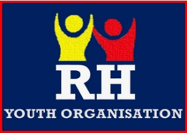
RH Youth Organisation
Lockerbie Old School HUB Package

Lockerbie Old School
Before we were established, we had begun forming a relationship with the Old School Committee. We have agreed that our projects, although viewed by many as similar, vary in many ways, and together we will be able to work together to reach the majority of the population of the local communities. We will be working together on important local issues as well as holding joint fundraisers in the future.
We know what benefits the Old School Project can bring to the local community and openly support the committee with its aims. We look forward to the project’s completion so we can benefit from their facilities. We believe that if we were to be as successful as we can be, we would require the majority of the storage and hall space that is available within the Old School. We already are running 4 sessions across three nights in the Lockerbie Branch and feel this would be unfair on the community as we would be effectively ‘taking over’ the community facility on the nights we run. We would also require a substantial, sizable area to run sessions and for storage, as we have large quantities of equipment for both our Theatre Group and Outdoor and Adventure Group. This would be detrimental to both the RH Youth Organisation and the Lockerbie Old School Community Hub. One facility that we also require is a garage to store our trailer(s) safely and securely. We rely on our trailer(s) to transport equipment to various locations – for example fundraisers and camping. A garage is required to protect the trailer(s) and ensure their maximum product life is met.
To solidify our strong relationship together we have established the RHYO/LOS Package. This includes advertisement for the Hub and joint fundraisers.

Joint Fundraisers for the RHYO & LOS-
We intend to hold joint fundraisers with the RHYO and LOS. This will result in larger community events which will have the potential to hold a higher profile in the area which may result in more funds being raised. These events will also promote cooperation and engagement within the community and will benefit both organisations.

What benefits could our two groups bring to LOS?
Helping with the upkeep of LOS garden area with our Outdoor & Adventure Group- weeding, planting, litter picking
As part of the Awards Programme, our young people have requirements to meet before gaining the award. Our Community Award consists of various requirements that can be met through cooperation with the LOS. For example –
• Plant and upkeep flowers/vegetables in the local garden
• Take part in a community project
• Make an impact on the local environment
• Take part in a litter pick

Using the HUB for Christmas Nativity/Carol singing with our Theatre Group.
We hope to hold an annual Christmas themed event at the LOS, like with our joint fundraisers, this will promote community cooperation and involvement whilst raising funds for our charities.

Advertisement of Lockerbie Old School HUB-
Banners can be displayed in key areas on the RHYO site, leaflets/posters can be displayed in our waiting area as well as on our website. We would help them get on the map!

Some of the activities we have done at the Old School-

Showing some support over social media

Lockerbie Old School attends our activity day

Lockerbie Old School Christmas Fayre November 2022

The RH Youth Organisation were invited by Lockerbie Old School to come along to their Christmas fayre. We had a stall there to promote our organisation and our Theatre Group members performed some Christmas dance routines to entertain the crowds.

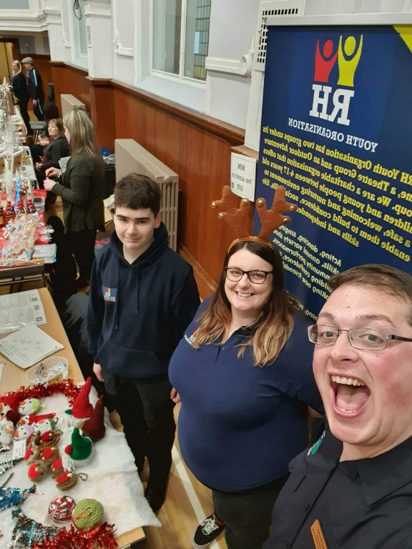

RHYO Winter Wonderland

We held our annual big Christmas fundraiser ‘Winter Wonderland’ at Lockerbie Town Hall. We had the Old School come along to sell tickets to their Christmas Cinema event and to display their plans of the hub to discuss their vision with members of the public who come along to our event.

Appendix 5

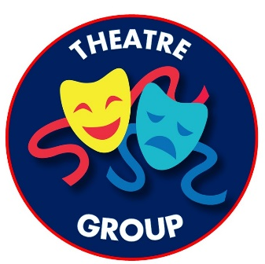

Scottish Charity Number- SC049696
Monday 22nd November 2021
Lockerbie Town Hall – Lesser Hall
6pm
Former Caravan Site Meeting Minutes
Present –
- Robert Humes – RH Youth Organisation
- James Craig – RH Youth Organisation
- Duncan Gracie – Lockerbie Ice Rink
- Andrew MacGregor and 2 other representatives – Lockerbie Squash Club
- Jodie Mason – Jodie’s Café
RH presented a PowerPoint presentation about the organisation and plans for the future regarding the Former Caravan Site. Presentation will be attached along with minutes
Questions and Concerns from Lockerbie Squash Club
- Parking. Where will the cars go?
We are hoping to keep traffic to a minimum with the majority of traffic on a continuous drop- flow. We will not be parking on Squash/Ice Rink premises. Parent’s/Guardians will be made fully aware of this. We will continue to investigate other solutions in order to keep cars at a minimum.
- Why have portacabin behind ice rink on their land? What about use of large green area at south of plan?
The proposed portacabin location in not located on ice rink property. We are proposing to place the portacabin on the former caravan site in a location where it will be mainly hidden from the main road by the ice rink. This location has been picked due to the flat landscape and close location to the interior road to allow for easy access to everyone including those with additional support needs. The large green area at the base of the plan is where we hope to one day build our headquarters. Due to the hill and distance from an interior through road, this would be difficult for disabled access to be maintained.
- Squash Club looking to expand. Will this interfere with plans and potential new car park?
Our plans do not interfere with the Squash Club’s plans for expansion of their building. Although, we are currently looking at obtaining ownership of the entire former caravan site, we are already aware that the Squash Club are looking to build a new car park on the land adjacent to their building. We understand their proposal and are willing to co-operate with them to discuss how both parties can be satisfied.
- If successful in full project, where will the HQ be located?
Pending feasibility studies and architect drawings, we are hoping that we can locate the main headquarters building on the hill at the south of the site.
- Do you have a power supply at the proposed portacabin location?
We will not have mains power supply whilst leasing the land and will run any power from a generator. If successful in obtaining ownership, we will then get mains supply connected.
Questions from Lockerbie Ice Rink
- Can the land be split?
Yes, the land could be split to a degree. For example, to ensure the squash club can build their new car park. This is something that will have to be discussed with each individual proposal.
- Will you have café?
No.
- Road up to T-Junction will have cars parked on it causing only a single line of moving traffic available
This is related to the car parking concerns raised by the squash club. This is something that we will investigate to minimise traffic at the site. However, traffic will not be continuous during our sessions, only during short periods at the beginning and end of the session. These equals 10 minute bursts 3 times a night maximum. Session times can be forwarded to all parties nearer the time we begin operations on the site.
Questions from Jodie’s Café
- Will you have a café?
No.
Before we closed the meeting, all parties were in agreeance that we must keep communications open and work together where possible. It was stated by all parties that the RH Youth Organisation’s long-term plans could provide benefit to all involved by attracting families to the area. This may cause an increased awareness of the ice rink and squash club.
Lockerbie Ice Rink currently have no major interest in the former caravan site and Lockerbie Squash Club are interested in only a small part, located adjacent to their building.
As detailed in the presentation, Lockerbie Squash Club expressed their interest in participating in a area activity day involving all parties present at this meeting.
Meeting Closed at 6.55pm

Appendix 6

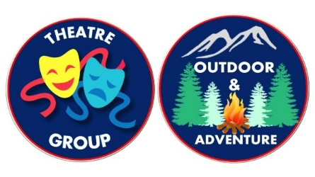
RH Youth Organisation
SC049696
Principal Office
38 West Acres
Lockerbie
DG11 2EL
07780648637

Date- 31st January 2023
Dear Lockerbie Ice-Rink,
We would like to thank you for your support letter for the RH Youth Organisation.
We would like to reassure you on your points made–
- The road on the south side of the facility will still have access to your customers for the Ice-Rink as this will be used as a through road for a one-way system for parent drop offs/collections and emergency services access.
- The refuse bins stand in our drawings provided by the architect will not be happening as volunteers have kindly offered to take away any rubbish after an event/ session.
- There will be no conflict with Jodie’s café as we have no intentions of having a café on our site and Jodie’s café has been a great support to our Organisation and we will continue to use Jodie’s café for our events, as we are all about giving back to our community.
- There are no plans for a fence to go round our activity centre. But will consider this for future funding applications.
- We are still in the planning stages of toilets. We are possibly looking at a port aloo that will be hidden behind large fencing panels to hide the toilet. The toilet will sit next to the portacabin to keep it altogether. We are looking at an eco water system tank (These facilities are still in the planning stages). We will notify you when this is fully confirmed.
- The activity centre will only be used for community drop ins/workshops, events, and our sessions.
We would like to conclude that Lockerbie Ice-Rink has been a fantastic support to the RH Youth Organisation. The support for holding our sessions, using the rink to dry our tents, the use of curling facilities and for the use of car parking for sessions/ events.
We are very much grateful for what you have done for our Young People, and we hope to continue our strong relationship for the near future.

On behalf of the Organisation, we thank you.

Your sincerely,
Robert Humes
Chief Executive of Outdoor & Adventure Group
of The RH Youth Organisation

Rebecca Humes
Chief Executive of Theatre Group
of The RH Youth Organisation

RH Youth Organisation
SC049696
Principal Office
38 West Acres
Lockerbie
DG11 2EL
07780648637

Date- 13th February 2023
The following questions have been answered by the RH Youth Organisation. We then forwarded this document to Lockerbie Ice-Rink. Below is their response email.

4) A secure fence being required but you will only consider it for future applications. Please can you confirm whether the Ice Rink are happy with this approach and when you would likely apply for this finding?
We would be looking at fencing when the Asset Transfer is complete as this is not our land at the moment. At this present time, we feel we do not need a fence as we would be doing our normal activities and normal events that we have done in the past. Nothing will be changing that will affect the Ice-rinks land. We always communicate with the ice-rink of our event plans as we would like to involve them and keep them in the loop. When we are successful with the Asset Transfer, we will be working closely with the Ice-rink regarding fencing etc. As we would like everybody’s input to our future plans.

5) Have the Ice Rink responded regarding the toilet facilities? Have you developed your plans further in this respect?
We would be putting down a disabled portaloo that will be hidden by large wooden fencing panels to hide the portaloo. This will be emptied regularly by a local company. This will be a temporary measure until the Asset Transfer is complete.

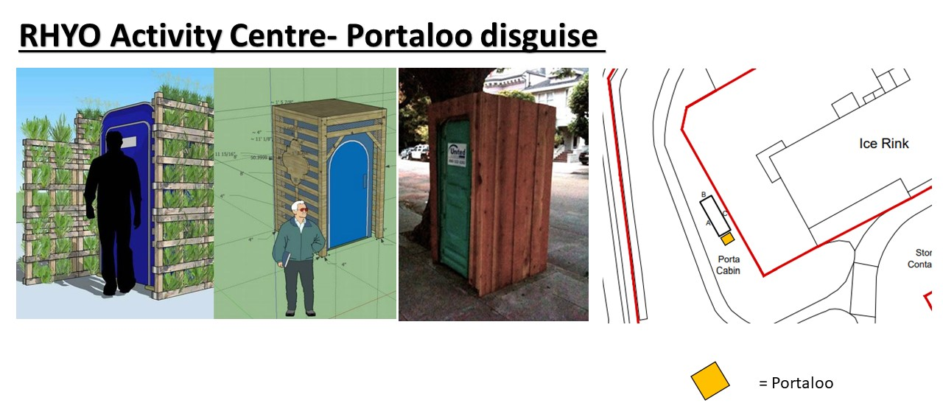

6) The Ice Rink asks that the RH facility is not in conflict with the Rink as they have meeting facilities, but your response states that it will be used for community drop in sessions. Please can you explain further how this will not conflict with the Ice Rink’s meeting facilities.

We will not be hiring the portacabin to any local groups/groups. The portacabin would be used for RHYO drop-in sessions ONLY. For example, we might hold an opening day were young people and adults can come along and have a taster session (on a theatre session or an outdoor session) The drop ins are part of our recruitment strategy. We hope to gain more young people and adult volunteers to help the organisation LEARN.DEVELOP.GROW. We will be able to show off wall presentations of young peoples work (photos, crafts, future plans, notice boards for parents/guardians for upcoming events) This will give the young people a chance to show off their achievements. The portacabin is for the young people of the RHYO and we want them to make it feel like its theirs and to be proud of it.
Eventually we will use the portacabin for activities for the local schools, community events and any other community groups in the area which would be run by the RHYO.

Lockerbie Ice-Rink Response-
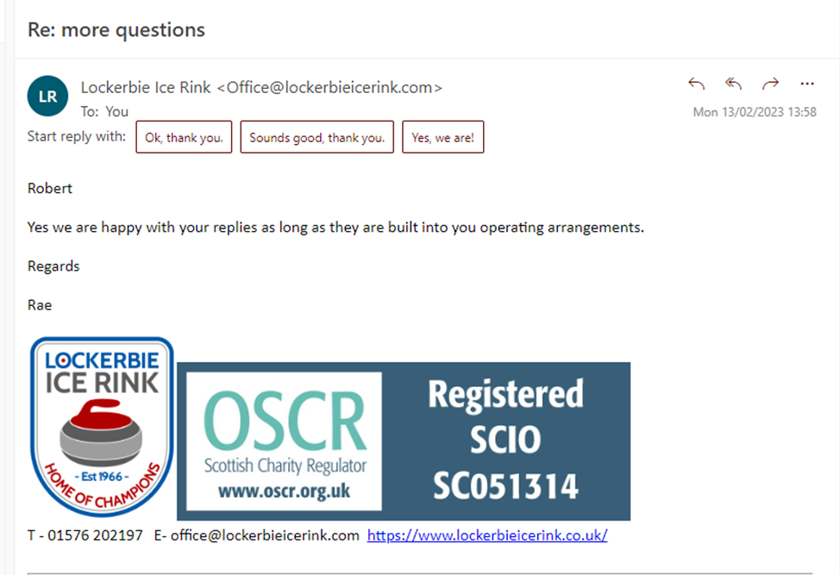

We would like to conclude that Lockerbie Ice-Rink and Lockerbie Old School are in favour for our project to take place with no conflict between all parties.

Your sincerely,
Robert Humes
Chief Executive of Outdoor & Adventure Group
of The RH Youth Organisation

Rebecca Humes
Chief Executive of Theatre Group
of The RH Youth Organisation

Appendix 7

