Section 4: Community Proposal
4.1 Please set out the reasons for making the request and how the land or building will be used. This should explain the objectives of your project, why there is a need for it, any development or changes you plan to make to the land or building, and any activities that will take place there

Summary-
Despite launching just nine weeks before the first Covid-19 lockdown, the RH Youth Organisation currently (January 2023) has 150 members which we aim to increase in line with our Ten-Year Strategy. We aim to continue increasing the variety of our activities and services with the use of already secured funding and future donations. We also intend to increase our volunteer numbers to help provide skills and support the organisation. Over the Ten-Year Strategy Plan, we will launch our Awards Programme, Young People’s Voice Programme, Young Team Leaders Programme, Schools Programme and the RHYO Community Programme.
The RH Youth Organisation Board now feel it is time to explore a more secure and permanent base through which the organisations goals for the future can be maximised and achieved.
We are currently in the process of a Community Asset Transfer to obtain the former Caravan Site located behind Lockerbie Ice Rink and believe that this land will be suitable as it is in close proximity to the town centre and the layout of the land would provide space for activities for the Organisation, community and surround communities and then eventually a building, including safe parking, adequate disabled access and situated within a prime location to enable the provision of community support and events. We require a premises that has suitable space, storage, garage, and facilities to enable an inclusive and equitable design - as well as an outdoor area to maintain our aims and rationale well into the future. We will also continue to build and enhance our strong connections with the community and other community groups for years to come through communication and maintaining strong relationships.
Once we have secured the land, we will begin launching our Community Programme. This will involve a Breakfast Club for children and young people, Get Together for members of the community, Food for Thought to support families in need and Community Recreation for all generations.
We have already carried out our first community consultation, in March 2021, which has given us positive feedback as well as suggestions for our project. We will carry out detailed consultations throughout the entire process of acquiring the land and building our premises.

Events-
Over the last 3 years, we have held an number of well attended events for the community on the land-
We have held-
- A Christmas Drive Through
- Easter Drive Through
- Annual Activity Days- This was supported by Amazing Summer Fund
- 999 Day
- Fireworks Event
All of our events have been well received from members of the public and we have had great feedback from them all.

Photos/Feedback can be seen on our Facebook page- https://www.facebook.com/rhyouthorg/

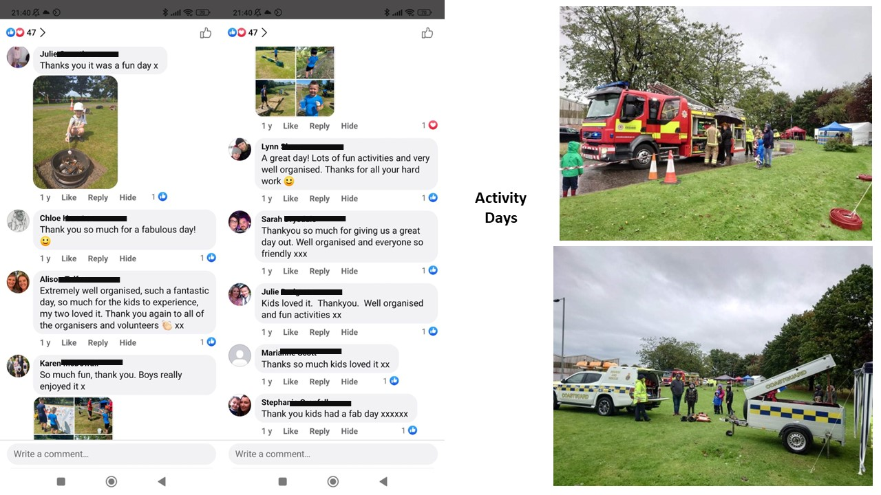
Event reviews-
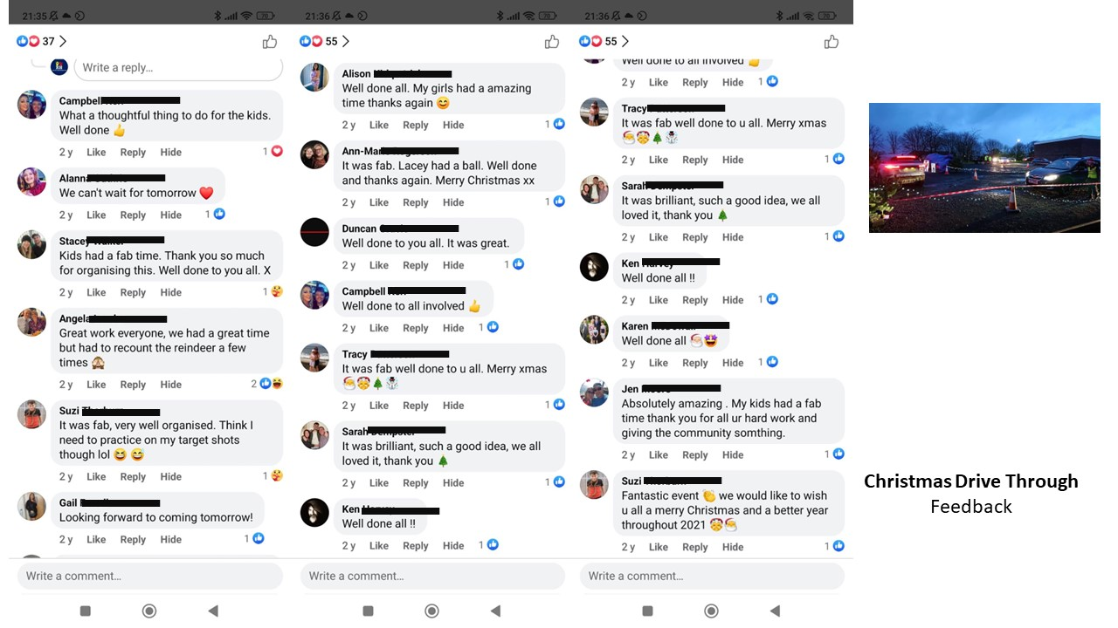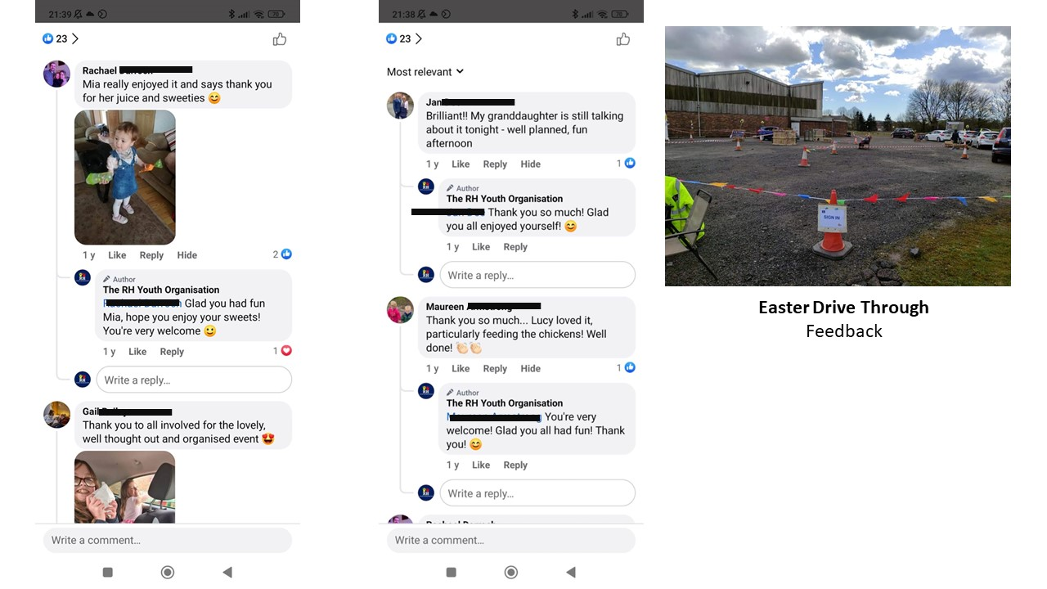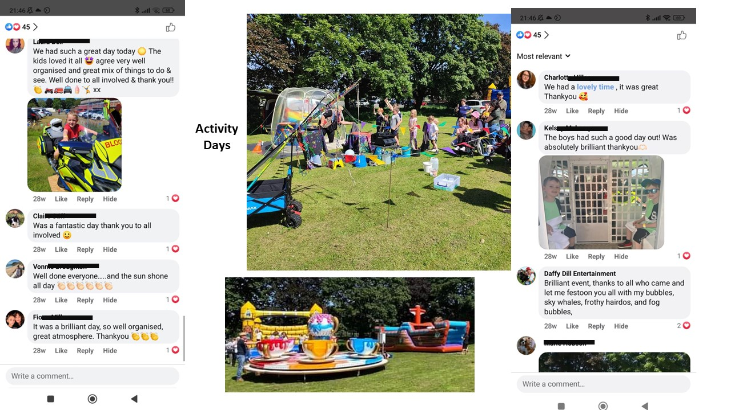
Our future events-

- Continue annual Activity Days and annual firework event.
- RHYO in the park- We hope to invite local talented young people and musicians to play in front of a crowd and celebrate music.
- Community BBQs’
- Opening Days
- Lockerbie Gala Fun Day
- Halloween Event

We can hold so many more events for the Organisation and Community when we have the land.

Research
When researching the demand for the types of activity our organisation provides, we referred to the Lockerbie Community Action Plan 2017. According to the plan there is strong opinion within the community that more youth groups and events for the children and young people is needed. 23.4% of all replies, when asked “What could be better about Lockerbie?” expressed views that more community events, activities and facilities for the children and young people and general upkeep of the town were all needed. For example, in answer to the question “What could be better about Lockerbie?” some of the replies are –
- Response number thirty-nine said – “More organised children’s events, youth events, and adult events.”
- Response number fifty-one said – “More for the youths.”
- Response number fifty-six said – “More things for young people to do a youth club of some sort for all ages at different times”
These are a just a few prime examples of the demand for our organisation and by listening to the views expressed in this consultation, we can achieve both the community’s and our own goals. All responses made can be found in Appendix 3 – Evidence of Demand from Lockerbie Community Action Plan with the answers relevant to our organisation highlighted in yellow.
With a broader view, we also have used the Scottish Government’s National Outcomes for Children and Young People and The Dumfries and Galloway Local Outcomes Improvement Plan to influence our organisations activities.
We believe that when our organisation achieves all the aims and targets laid out in this business plan, we will be working towards and complementing the council’s objectives in achieving at least five of the seventeen United Nations Sustainable Development Goals. These five are included in the Scottish National Outcomes and are as follows:
- Goal 1 – No Poverty
- Goal 2 – Zero Hunger
- Goal 3 – Good Health and Well-Being
- Goal 4 – Quality Education
- Goal 10 – Reduced Inequalities
The Dumfries and Galloway Local Outcomes Improvement Plan consists of eight outcomes, most of which we can align ourselves with. We aim to include parts of five outcomes in our organisation’s long term plan by 2026 – for example:
- Outcome 2 – Learning opportunities are available to those who need them most.
- Outcome 8 – Individuals and communities are empowered.
A full account of the Local Outcomes we intend to work towards can be found in Appendix 1 – Dumfries and Galloway Local Outcomes Improvement Plan.
We also will align our organisation with the Dumfries and Galloway Children’s Service Plan 2020-2023 as the priorities stated in the plan are similar to our own aims and objectives. The council’s plan’s priorities are –
- Priority 1 – We will ensure that our children and young people are safe and free from harm.
- Priority 2 - We will ensure children and young people get support at the earliest appropriate time through prevention and early intervention.
- Priority 3 - We will improve the wellbeing and life chances of our most vulnerable children and young people.
- Priority 4 - We will work to reduce or remove barriers so that all children and young people have equity of opportunity.
- Priority 5 - We will deliver the best possible health and wellbeing for all children and young people.
- Priority 6 – We will raise attainment and be ambitious for all children and young people
We aim to replicate the objectives and outcomes from the Dumfries and Galloway Antisocial Behaviour Strategy 2020-2024 through early intervention and community engagement. We aim to create a safe environment where children and young people want to be which in turn will result in reduced antisocial behaviour levels in the community. We will work with our members and the community to ensure awareness of our community’s needs are upheld.
During 2020, we sampled a percentage of our service users to receive initial feedback about the activities we are providing. A handful of the testimonials that we received can be found in Appendix 2 – Testimonials
At the end of February 2021, we issued our first community consultation to the public as community support and awareness are required in order to proceed. In the first two weeks, we received fifty responses with almost all showing positive results. We asked three questions which concerned the benefits and likelihood of use of the services that we want to provide which are laid out in this business plan. Our responses showed that 76% of people surveyed believe that our Breakfast Club would be beneficial to themselves and the community, whereas 96% believe our Community Recreation Programme will benefit the community. 52% of those surveyed gave us extra information/suggestions to be included.
Community consultation is an important part of this project and surveys will be issued to the public and businesses at various stages throughout the process. Survey 1 – 26/02/2021-12/03/2021 can be found in Appendix 4.

Aims & Objectives
Target 1: Provide an inexpensive experience which will help reduce social exclusion.

Rationale: All members must pay the necessary costs. This is £1.50 a session and a £10 yearly fee to cover our insurance costs. These figures are as low as possible in order to reduce social exclusion. However, we are aware that not everybody is able to pay the fees hence why we have been working on a solution. To help us reach this target, one of our solutions is the RH Youth Organisation Youth Support Package.

Outcome: The Youth Support Package consists of 2 packs.
Pack 1 consists of Financial Aid which may cover costings of camps, outings, insurance and fees.
Pack 2 consists of equipment aid which can include uniform, rucksacks, sleeping bags and rollmats.

There is a uniform for our organisation but until the appropriate funding is secured, this is only a suggestion and is not being enforced. In line with our aims, we do not want to increase the financial burden of families and stop children and young people from learning, developing and growing within our organisation due to a lack of funds.

We will always do our best to keep all costs to a minimum. We also aim to build trusting relationships with the parents/guardians to a point where they feel comfortable enough to talk to us directly and voice any worries, questions or concerns that they have. If they have any concerns about finance, we can answer their questions and reassure them that we will do our best to accommodate their needs. All information about the Youth Support Package is in our policies.

We will be applying for grants regularly in order to maintain Pack 1 and we believe that this is an achievable target as we are already keeping cost to a minimum and with the help of a small grant, have already set up the financial aid package.

Target 2: Provide activities that will be skills based, therefore allowing the young people to gain skills for life, skills for the future and skills for the world of work.

Rationale: We want to promote various skills that the children and Young People can retain and use for the rest of their lives. We recognised that there was a need for our organisation in the local community as there is no or limited provision for theatre or outdoor groups specifically for children and Young People in the community. This means there is a market for our organisation to help build confidence, use imagination, creativity and allow them to express themselves as individuals through a range of medias.

Outcome: Our aim is to provide opportunities for different age groups. Most of the equipment we use in the Organisation will be used across the age groups but there will of course be items that are required to suit the ages and stages of individual needs and development. For example, games equipment and sensory equipment.

Both groups of our organisation aim to develop children's and Young People's metaskills such as confidence, resilience, self-esteem, and creativity. We will be working to implement our Awards Programme once we can safely reopen the whole organisation. There will be many requirements that will be needed to be completed to gain their certificate. The Young People will have a chance to provide their input to these awards once they are officially launched.

Around the same time, we will be launching our Young People’s Voice Programme, which will further allow for their input to the design and delivery of activities provided. Some of their responsibilities will include forming an eco-group and appointing a small group of representatives from each session, who will gather ideas and suggestions from others, to inform the Board at least twice a year to ensure the Young People’s voice is heard throughout the whole organisation.

Another award we will make available is our Young Team Leader Award. This programme will boost youth participation by including Young People aged 14-17 in the planning as if they were an adult volunteer. This programme will provide extra responsibility to these Young People as to complete the award they must run a session with the assistance of the Adult Team. All our activities and sessions are planned around what the Young People tell us they would like to do. For example, on the first week of running the sessions each term, we consult with each session on different ideas and activities they wanted to do throughout the year. Any Young People, both in and out with the organisation have the opportunity to be guided through other awards such as the Duke of Edinburgh and Saltire Awards.

Target 3: Offer the opportunity for Young People and adults to gain volunteering experience.

Rationale: We want to effectively utilise our volunteers' skills and varying abilities to ensure that all our children and Young People can be involved a wider and broader experience.

Outcome: This will develop their confidence and utilising their skills and talents will complement the overall programme of activities. Team Members have a monthly session plan meeting where they can voice their opinions and ideas for the next block of sessions.

Our Young Team Leader Award will also be launched which will boost youth participation by including Young People aged 14-17 in the planning as if they were an adult volunteer. This programme will provide extra responsibility to these Young People as to complete the award they must run a session with the assistance of the adult team and is great experience to put on a future CV. Any Young People, both in and out with the organisation have the opportunity to be guided through other awards such as the Duke of Edinburgh and Saltire Awards.

Target 4: Provide recreational activities that will benefit the young people by offering an equitable, inclusive and nurturing environment.

Outcome: Before anyone can become a Team Member, they must undergo a PVG check, provide a reference and undertake our Training Programme. We have developed this programme to ensure that all our adult volunteers are equipped with the necessary skills to provide a varied and balanced session plan and become good role models to all our members. They are taught about session planning, positive attitudes/behaviour and child protection procedures as well as much more. All our sessions provide a nurturing environment where children feel safe and secure. They are able to express themselves and make their needs known with confidence. This has been recognised by parents and carers and comments can be viewed in the review section on our public Facebook.
We aim to provide an inexpensive experience which will help reduce social exclusion and to help us do this, we have introduced the RH Youth Organisation Youth Support Package.

The Youth Support Package consists of 2 packs.
Pack 1 consists of Financial Aid which may cover costings of camps, outings, insurance and fees.
Pack 2 consists of equipment aid which can include uniform, rucksacks, sleeping bags and rollmats.

There is a uniform for our organisation but until the appropriate funding has been secured, this is only a suggestion and is not being enforced. In line with our aims, we do not want to increase the financial burden of families and stop children and young people from learning, developing and growing within our organisation due to monetary issues. We will always do our best to keep all costs to a minimum.

From our March 2020 data, we know that around a third of our members have an additional/medical need and we will always do our best to ensure that they feel welcome and nurtured whilst at the RH Youth Organisation. Our younger sessions came up with their own rules and boundaries for themselves when attending the sessions and a code of conduct is signed by all members in the older sessions. These rules will ensure that everyone at the RH Youth Organisation is safe, respected and nurtured whilst still ensuring that all members can enjoy the session and continue to learn.

Target 5: Offer a variety of services through our Community Programme.

Rationale: Social isolation, depression and loneliness are an increasing concern, not only for the NHS but for families who may be situated a long way from vulnerable members of their families. From members own observations of acquaintances and knowledge of their own localities, the RH Youth Organisation feel that this is an area in which they could reach out to offer something which not only brings people together but may give purpose to those who do not otherwise have opportunity or reason to leave their homes.

Outcome: We aim to offer a nonthreatening environment whereby there is no obligation, commitment or expectation other than to come along, be part of a friendly environment, have refreshments, games, activity, interesting speakers or skills-based visitor purely targeted at the participants interests and areas of enjoyment. We feel that by offering such an opportunity would gently ease those in self-insolation back into an environment which would develop personal confidence, self-worth and fulfilment.

Monitoring and Evaluation

Monitoring and Evaluation of the RH Youth Organisation is an important feature of ensuring and maintaining a quality service to their children, young people and adult volunteers.
It is seen as a crucial part of sustaining the essential criteria which is required by OSCR and funding streams.

A monitoring programme will guarantee that the evaluation of the service is consistent and robust and will inform future development and progression.
Monitoring and evaluating the quality of interaction with children by volunteers will in the first instance be made by the team leaders. For example, Parents/Guardians will be receiving feedback forms to enable the adult volunteers to learn and improve the sessions in order to better suit the need of our individuals.

Monitoring of team leaders will be made by the chief executives and the monitoring of Chief Executives will be made by the RH Youth Organisation Board.

Financial scrutiny in the first instance will be overseen by the Organisation Treasurer
Monitoring of activities and resources will be made by the Chief Executive team.

External scrutiny will be made by OSCR and financial scrutiny by the accountant verifying the accounts.

Measures will be put into place to ensure that the RH Youth Organisation are providing a quality experience and are also meeting their aims, objectives and criteria of overseeing bodies (OSCR, funding bodies).

Evaluation will be requested periodically from all members of the RH Youth Organisation in the form of questionnaires, surveys and verbally.
Records will be kept to monitor suggestion, changes made and impact of the service as a whole on the community.

Measures such as run charts, graphical and statistical information will be captured to provide a visual overview of progress.
PDSA (Plan, Do, Study, Act) cycles will be used where small tests of change are to be trialed before full rollout and implementation of major change.

All of this should result in higher attendance numbers and more children and Young People signing up and attending regularly. We will regularly send out evaluation forms to establish success considering parent/guardian's feedback and working with them to improve our service. The Executive Team and Board Members will hold a minuted quarterly Monitoring Meeting in order to assess if the organisation on track to achieve its aims. All adult volunteers will also be monitored at the weekly sessions by the Team Leader and if any training is deemed to be necessary, the appropriate courses will be sourced. All observations will result in the appropriate actions being taken to ensure that we as an organisation can do everything possible to improve the service that we provide to the children and Young People.

Dumfries and Galloway Children’s Services Plan 2020 – 2023

(Dumfries and Galloway Council, 2020a)

Dumfries and Galloway Anti

Appendix 1 – Dumfries and Galloway Local Outcomes Improvements Plan 2017- 2027

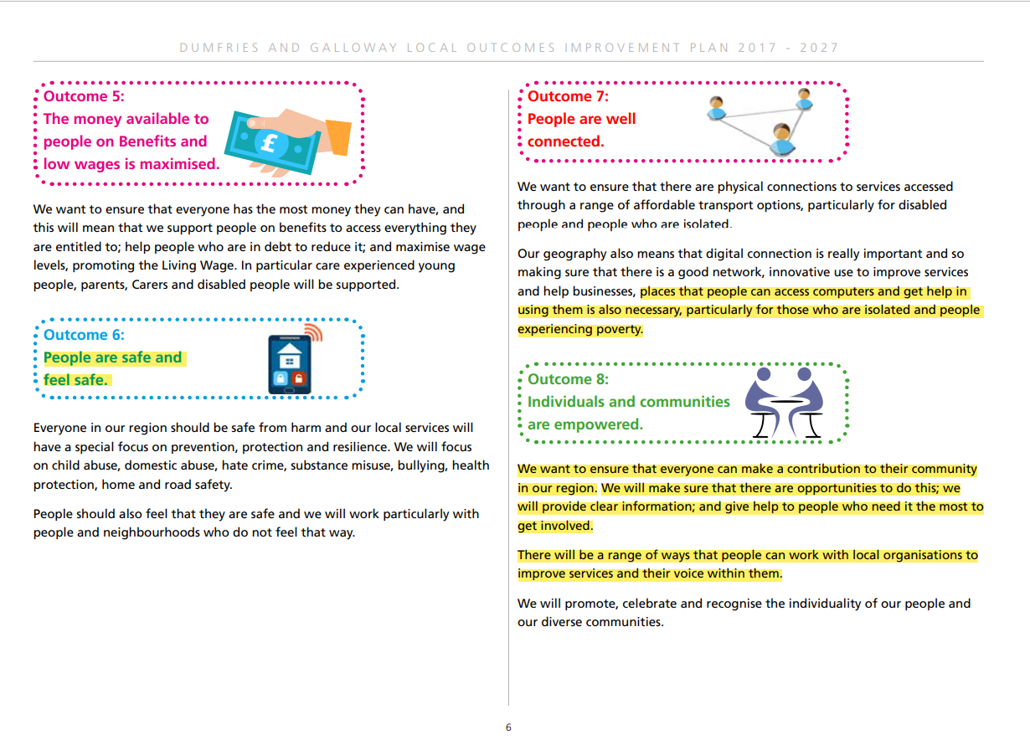

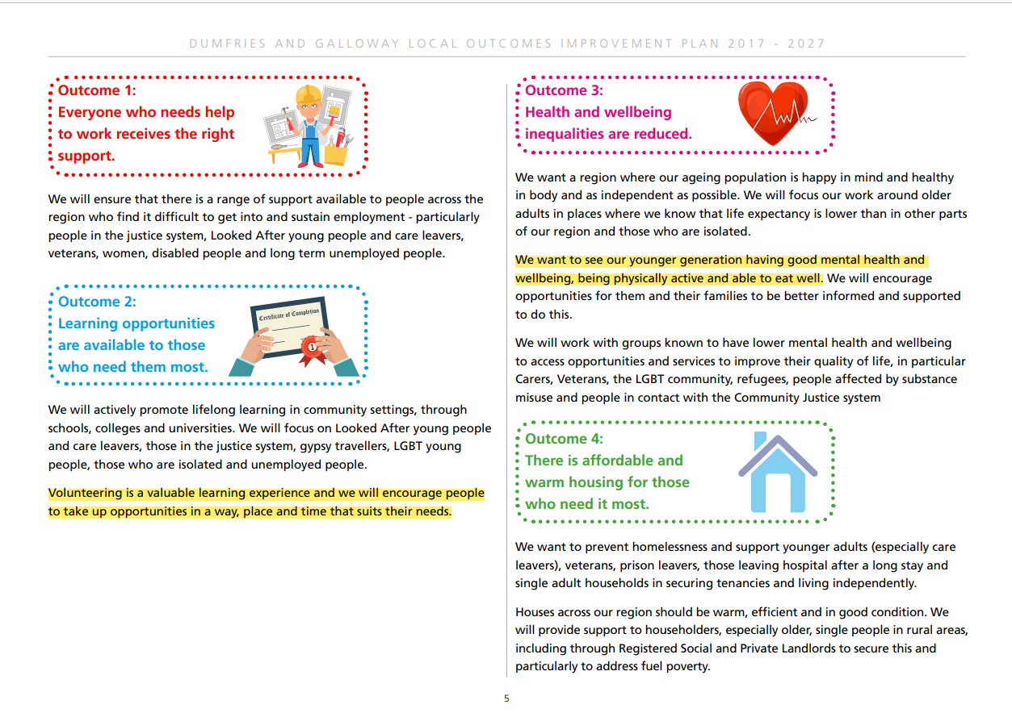

Appendix 2 – Testimonials

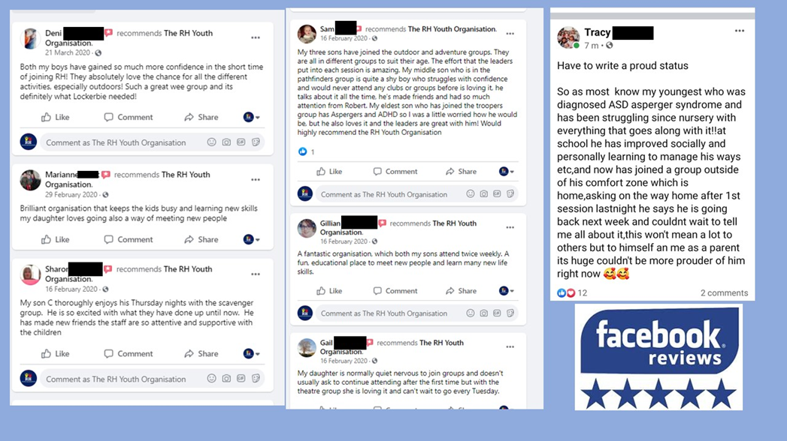

Appendix 3 – Evidence of Demand from the Lockerbie Community Action Plan

Appendix 4

Q3) Thinking of the services in Q1, can you think of anything else our building and land could be used for to support the community?
- Inter generational activities. Swap shop for clothing.
- Somewhere for mums and babies / toddlers to meet .
- As a mum with young children, it sounds like the ideal space for baby and toddler groups to meet for playing indoors and outside. Sounds like a fantastic facility!
- Wishing you all in the best. Really hope you can make your vision a reality. It all sounds fantastic and just what Lockerbie needs. Good luck :)
- A safe space
- Baby groups, children from schools to help plant and grow, grow fruit and veg for community to pick, craft demonstrations and activities, community toilets
- A lot of thought gone into this, especially for the community. Lockerbie could do with some extra features. My grandchildren would love an area like this to spend a day in. I hope you have everyone's back for this.
- I think what you have is ideal to open up loads of options for the community, especially families. You’re allowing people the option to have a day out in Lockerbie! Something nobody thought they would ever say!
- Hi, we just moved into the area last year. We have 2 children and one dog. Once restrictions lift and when your club reopens again I intend to try and get my two children to come along to your Outdoor club. What a fantastic way to get the children outside (my two love the PS4!) My family would love to come and spend the day at your new site. Will the path be suitable to ride bikes along? We go biking in the Mabie forest on the weekends the bike park looks awesome! My dog will love the pet area. Hope the site goes ahead!
- WOW, Exciting project! Huge space to work with. You may have covered this but just a few questions. Will there be a cost to use the dog area and bike area? Who will maintain the areas? Wonderful idea for all.
- Hi, Me and my husband walk our two dogs in the large grass area behind the Ice-Rink. We feel that this project would benefit us. We like the idea of a path that leads to the dog run. Our two dogs would love the freedom to run about! The idea of picnic benches along the way will be lovely in summer time. One question I have is will there be toilet facilities for large families who may come for the day? This is a lovely idea and we wish you all the best!
- I think that this is a great idea. Having been in Lockerbie for many years, I can see how this group, building and all the service listed can benefit so many people in the community. I really hope this goes ahead and is built quickly as the facilities are needed.
- Think you have covered a good variety of things. Maybe outside exercise equipment
- This looks like an interesting project. I hope it will be maintained well to keep clean and tidy, for example dog poo! Our street is awful for it! I like the idea of an outdoor park area for my 2 kids.
- My kids love biking and are always looking for somewhere new to play. The bike park sounds great. Im not a dog owner, but having an area where people can bring their dogs so that they can run free and play safely sounds great!
- Looks good Need something new in Lockerbie
- I think this is a great idea that will bring together all ages. This could be further encouraged by a lunch club for adults, particularly the over 65's. Perhaps you could have this linked to the school for work experience or for kids to volunteer.this would decrease loneliness for the elderly as well as giving young adults work experience for their life skills and CV's. Could also have a food bank for those living in poverty. Disabled access/ exclusive play park. Picnic areas.
- Build it now pls :)
- This would be a fantastic enterprise to the community. Hope this succeeds!
- Forming links with the elderly
- Somewhere ‘classes’ could be held eg. crookmaking, cookery, local crafting. Somewhere that might support local businesses - eg millinery, flower arranging, photography, specialised crafts. A venue which could be used to support local businesses to market their goods eg. local producers, people that don’t have a shop space, people who run part time businesses. Refreshments on site -available to purchase during activities (vending machine style so it doesn’t impact on existing business)
- Toilet facilities would be an advantage but they may be accessible inside the building.
- An activity hall or outdoor area for sporting activities such as football, basketball, badminton ect.
- Would love to see something that involves both the younger generation and the older generation mix and come together! I know MAP (the nursery) sometimes visits the carehomes but thats maybe something yous could bring to your wee hub for tea/juice and fun! well done guys, you’s are absolutely amazing!
- Cinema
- Baby and toddler groups

