DUMFRIES AND GALLOWAY COUNCIL
DUMFRIES COMMON GOOD GRAYLING RULES 2024
FISHINGS MAY BE RESTRICTED IN LINE WITH PUBLIC HEALTH ADVICE AT SHORT NOTICE.

THE SALMON FISHINGS AND GRAYLING /S UNDAY FISHINGS HAVE SLIGHTLY DIFFERENT PERMITTED AREAS TO FISH. PLEASE CHECK MAP

- Permit holders must fish only waters controlled by Dumfries Common Good and respect adjoining Fishing. NOTE: The permitted areas differ from those available to Salmon fishing and are outlined on the Fishing Map.
- Anglers must show permits when requested by Bailiffs, Police and authorised personnel acting on behalf of Dumfries Common Good.
- Tickets for Grayling Fishing are available from 1st December to 24th February.
- Fly and Bait fishing only - no ground baiting.
- Maximum breaking strain of line is 4 lb.
- Bait fishing maximum hook size, no larger than size 12s barbless single hooks only, maximum 3 SSG splitshots or equivalent to 5 grams, maggots or small worms only ( around 1 inch long ) bait must be kept moving at all times.
- Fly Fishing; flies no larger than size 12s single barbless hooks only.
- Only one rod to be used and to be held at all times
- Catch limit; Only 2 Grayling to be retained each day. Catch and release is promoted.
- NO SHUFFLING ALLOWED
- No deep wading allowed.
- Be aware of and avoid salmon reeds
- Always fish in a sporting manner and respect fellow anglers

- Fishing from daybreak until dusk.
- Grayling close season 15th March to 16th June.
- Dumfries Common Good accepts no responsibility for any loss or damage to any property or motor vehicles while on any part of fishings controlled by Dumfries Common Good.
- Catch return data must be provided, including catch and release and nil returns.
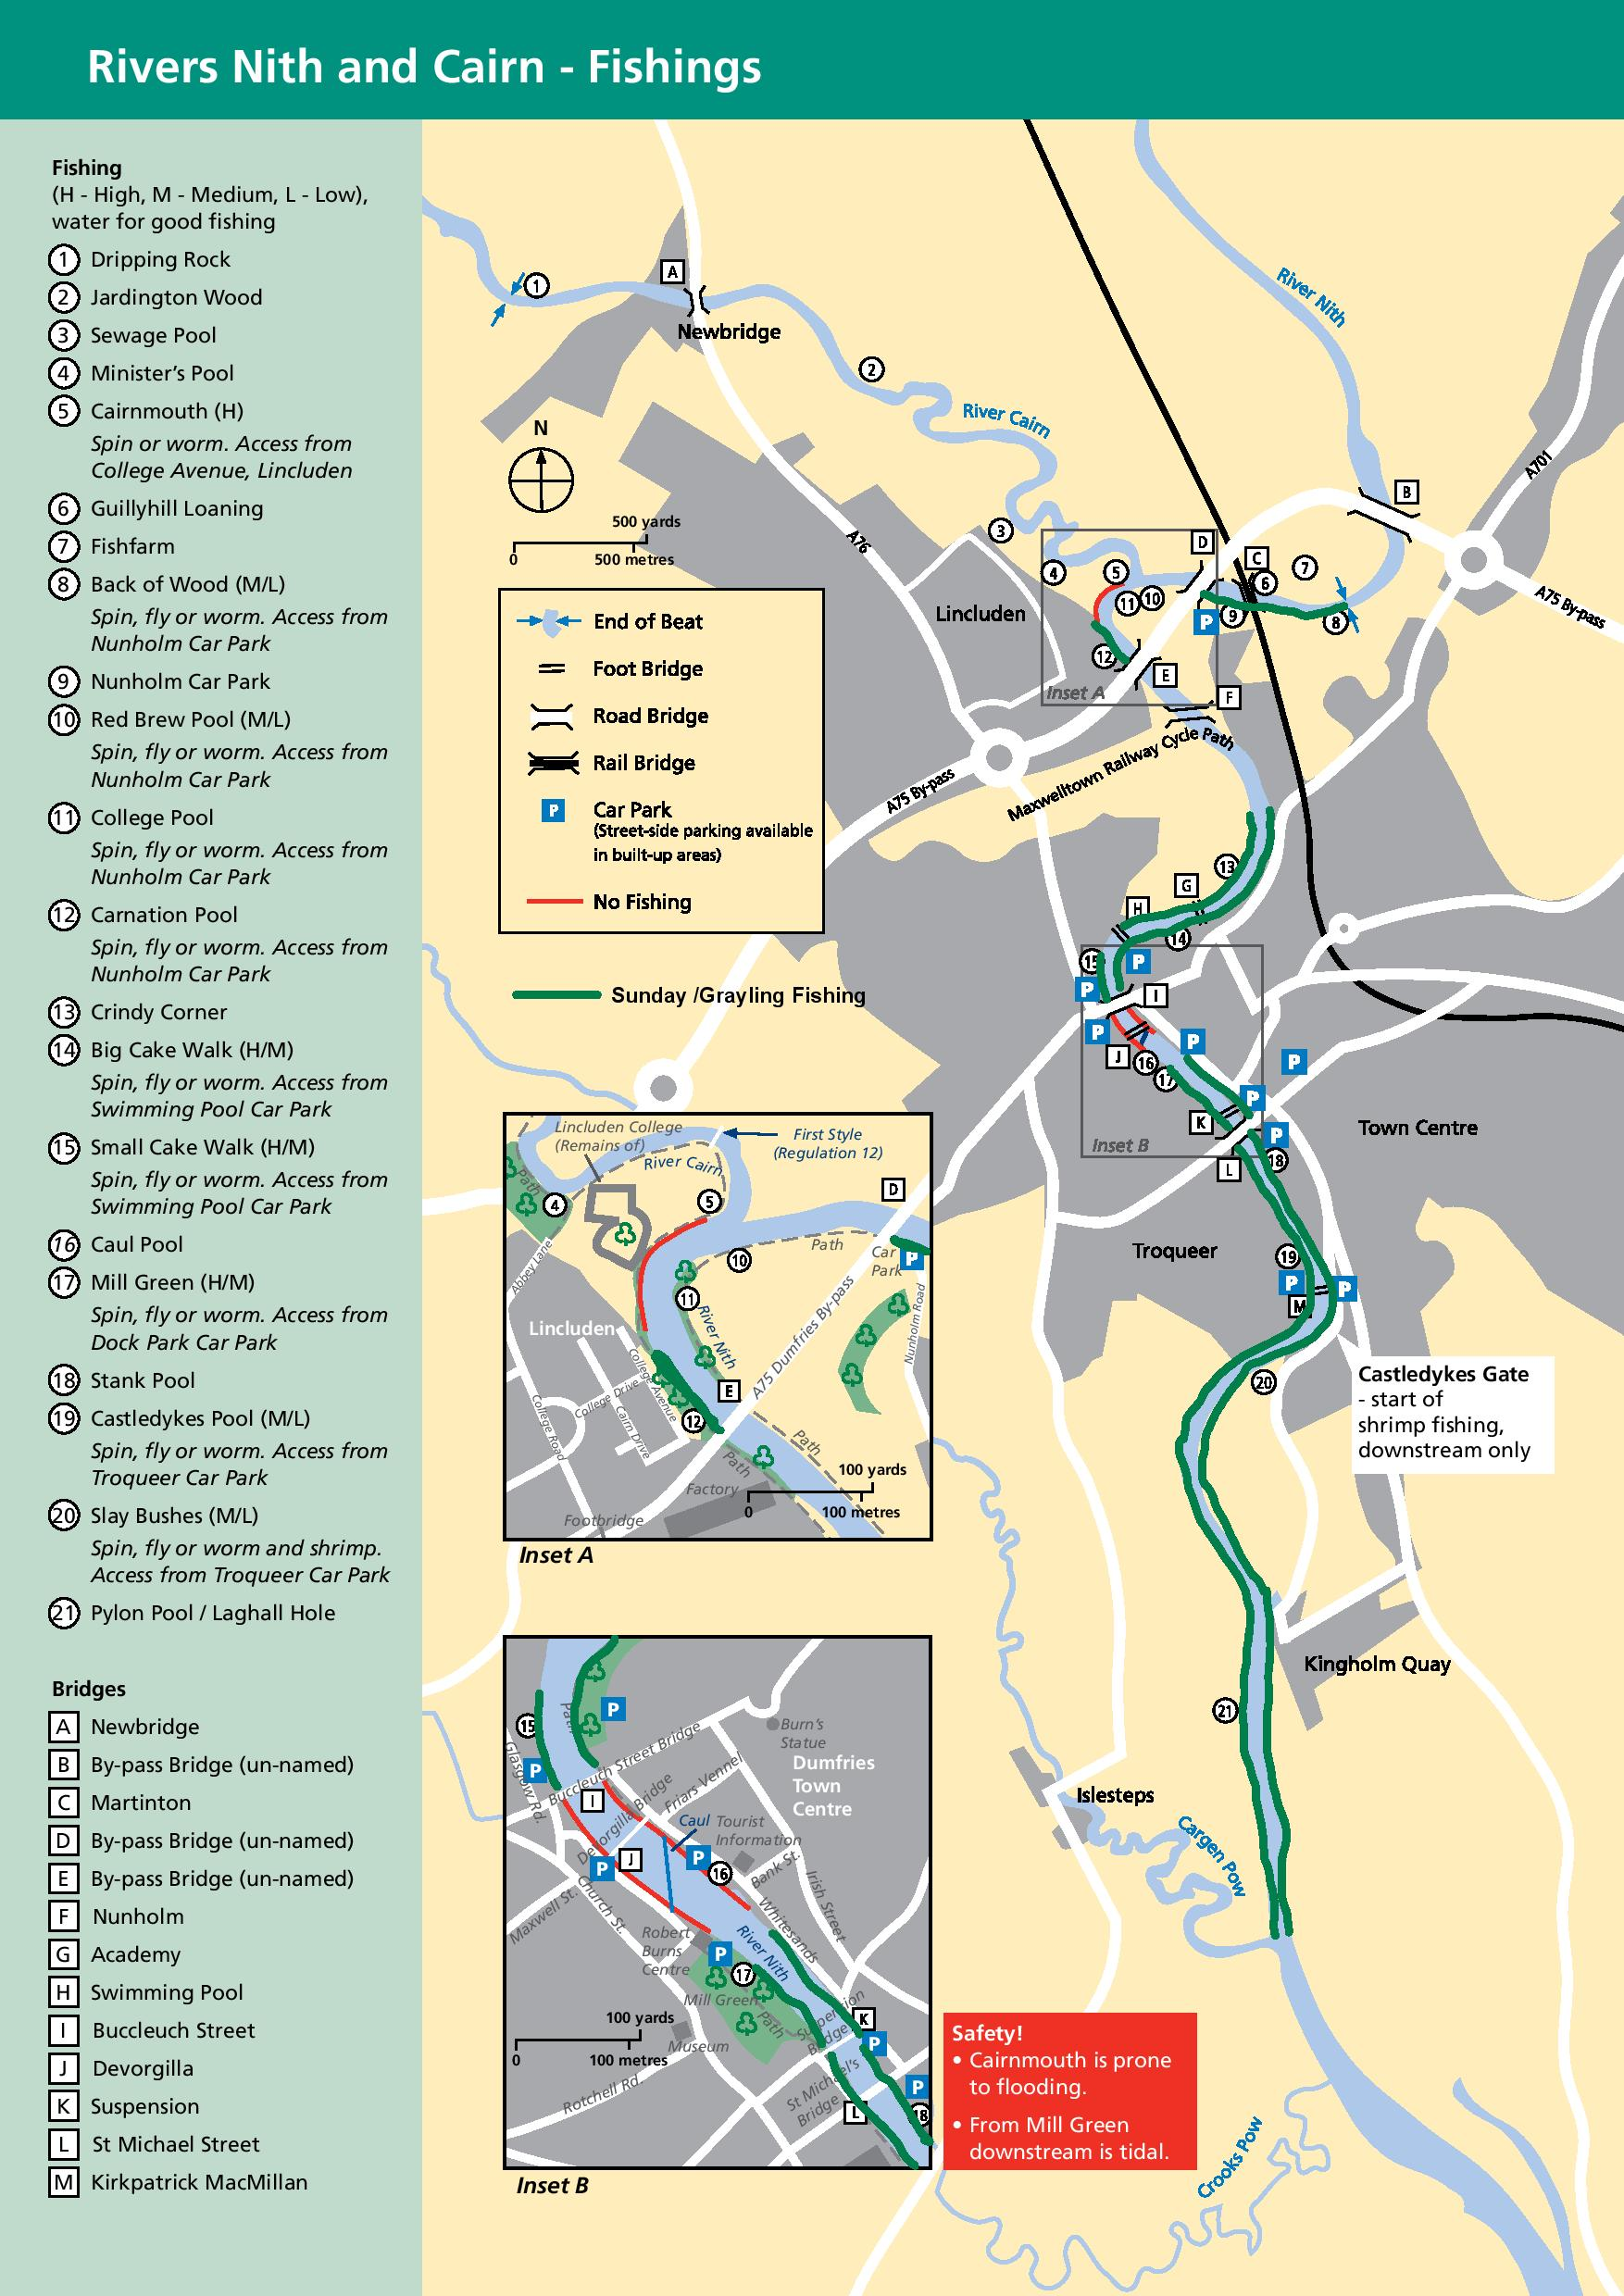
USEFUL CONTACTS
Water Bailiff 07785 743663 Police 101/999
Dumfries and Galloway Council 030 33 33 3000

