Community Resilience

**Local Plan**





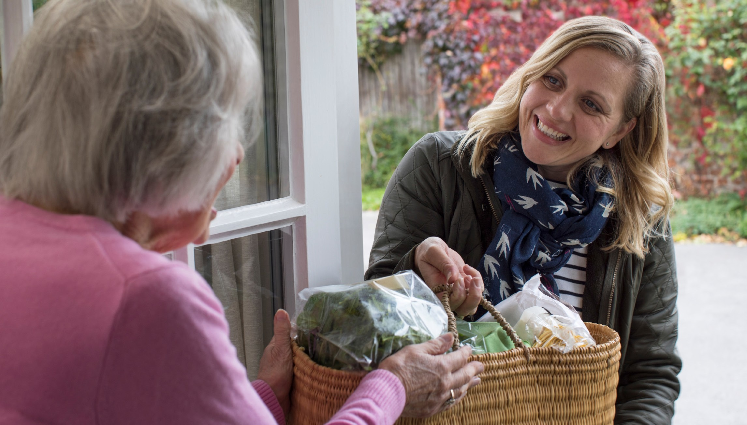

**Your Community Resilience Local Plan**

|  |
| --- |
|  |

**If anyone is in immediate danger call 999**

|  |  |
| --- | --- |
| **We are Community Council affiliated** |  |
|  | |
| **We are an Independent Group** |  |
| **Please tick above**  If your Community Resilience Team is affiliated to your Community Council, then Community Resilience Insurance is already in place for you. See Annex E, Insurance Information | |

**Contents**

Amendments to Plan 4

Community Response Team 5/6

Community Response Team - Volunteers 7/8

Neighbouring Resilience Teams 8

Links with online “Pop-Up” Groups 8

Community Resources 9

Main Community Facility 10

Food Provision/Providers/Support 11

Key Contact Information 12/13

Local Risk Assessment 14

Guidance Notes 15/16

Scenario Assessments 17

Roles 18

**ANNEXES**

Annex A - Emergency Action Checklist 19

Annex B - Logging Sheet 20

Annex C – Community Maps & Key Buildings 21/22

Annex D - Restricted Information 23

Annex E - Insurance Information 24

Annex F – GDPR 25

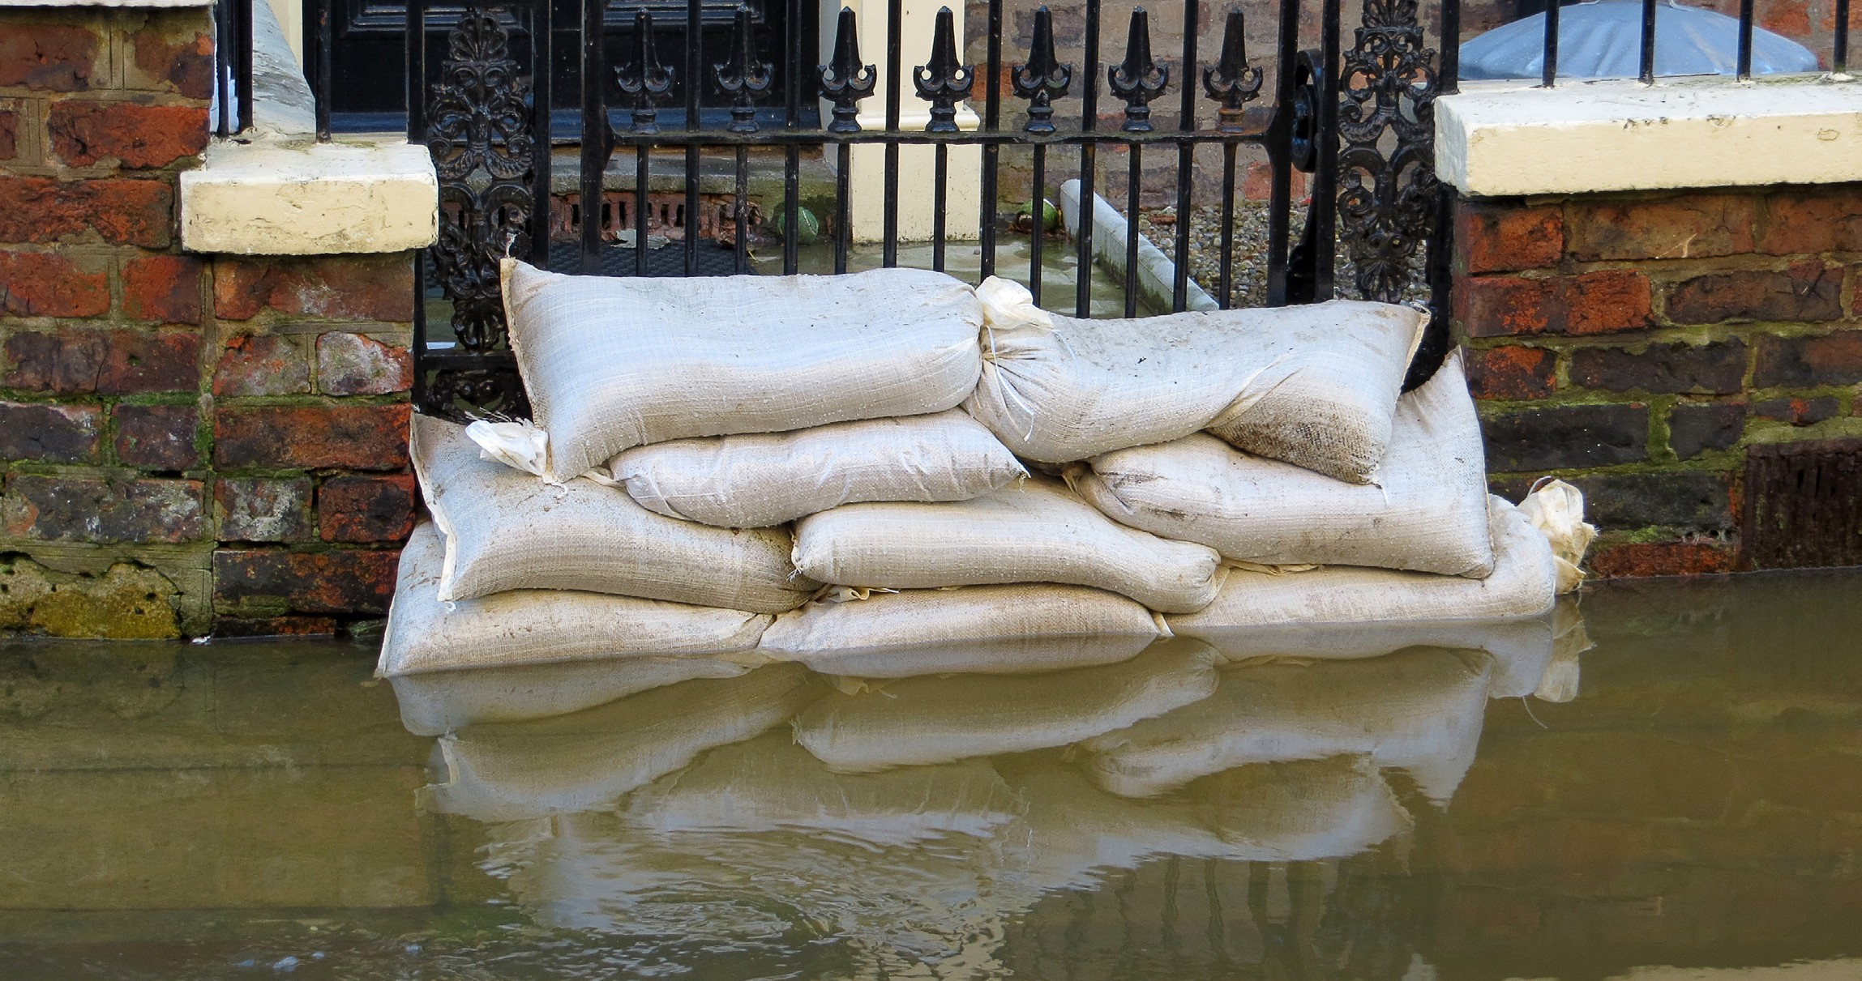Disclaimer 26

**Amendments to Plan (Please inform your** [**Local Ward Officer**](https://www.dumgal.gov.uk/article/16447/Ward-working)**/Resilience Team)**

|  |  |  |  |
| --- | --- | --- | --- |
| **Name** | **Page**  **Number** | **Reason for amendment** | **Date** |
|  |  |  |  |
|  |  |  |  |
|  |  |  |  |
|  |  |  |  |
|  |  |  |  |
|  |  |  |  |
|  |  |  |  |
|  |  |  |  |
|  |  |  |  |
|  |  |  |  |
|  |  |  |  |
|  |  |  |  |
|  |  |  |  |
|  |  |  |  |
|  |  |  |  |
|  |  |  |  |
|  |  |  |  |
|  |  |  |  |
|  |  |  |  |
|  |  |  |  |

**Community Response Team**

The Community Response Team (CRT) plans and co-ordinates the support to the community alongside the responding agencies to ensure that vulnerable people are supported and to promote self-help to householders. They are also responsible for keeping the plan updated.

|  |  |  |  |  |
| --- | --- | --- | --- | --- |
| **Role** | **Name** | **Email** | **Mobile** | **Address & Postcode** |
| Coordinator |  |  |  |  |
| Deputy |  |  |  |  |
| Team Member |  |  |  |  |
| Team Member |  |  |  |  |
| Team Member |  |  |  |  |
| Team Member |  |  |  |  |
| Team Member |  |  |  |  |
| Team Member |  |  |  |  |
| Team Member |  |  |  |  |
| Team Member |  |  |  |  |
| Team Member |  |  |  |  |
| Team Member |  |  |  |  |
| Team Member |  |  |  |  |
| Team Member |  |  |  |  |
| Team Member |  |  |  |  |
| Team Member |  |  |  |  |
| Team Member |  |  |  |  |
| Team Member |  |  |  |  |
| Team Member |  |  |  |  |
| Team Member |  |  |  |  |
| Team Member |  |  |  |  |
| Team Member |  |  |  |  |
| Team Member |  |  |  |  |
| Team Member |  |  |  |  |
| Team Member |  |  |  |  |
| Team Member |  |  |  |  |
| Team Member |  |  |  |  |
| Team Member |  |  |  |  |

**Community Response Team - Volunteers**

(Not permanent Team Members but willing to assist in an emergency when extra resources are required)

|  |  |  |  |  |
| --- | --- | --- | --- | --- |
| **Role** | **Name** | **Email** | **Mobile** | **Address & Postcode** |
| Volunteer |  |  |  |  |
| Volunteer |  |  |  |  |
| Volunteer |  |  |  |  |
| Volunteer |  |  |  |  |
| Volunteer |  |  |  |  |
| Volunteer |  |  |  |  |
| Volunteer |  |  |  |  |
| Volunteer |  |  |  |  |
| Volunteer |  |  |  |  |
| Volunteer |  |  |  |  |
| Volunteer |  |  |  |  |
| Volunteer |  |  |  |  |
| Volunteer |  |  |  |  |
| Volunteer |  |  |  |  |
| Volunteer |  |  |  |  |
| Volunteer |  |  |  |  |
| Volunteer |  |  |  |  |
| Volunteer |  |  |  |  |
| Volunteer |  |  |  |  |
| Volunteer |  |  |  |  |
| Volunteer |  |  |  |  |

|  |  |  |
| --- | --- | --- |
| **Neighbouring Resilience Teams** | | |
| **Community** | **Name** | **Contact Details** |
|  |  |  |
|  |  |  |
|  |  |  |
|  |  |  |
|  |  |  |
|  |  |  |
|  |  |  |

|  |  |  |
| --- | --- | --- |
| Links with Online “Pop-Up Groups” | | |
| **Name** | **Contact Details** | **Web / Facebook / Twitter etc. links** |
|  |  |  |
|  |  |  |
|  |  |  |
|  |  |  |

**Community Resources**

Key resources available to support the local community should be listed here.

|  |  |  |  |
| --- | --- | --- | --- |
| **Resource** | **Contact / Key Holder** | **Conditions of use** | **Additional Information** |
| Public Access Defibrillator |  |  |  |
| Fresh water/drinking source |  |  |  |
| Tractors |  |  |  |
| Transport (4x4s) |  |  |  |
| Generators/heaters gas/electric |  |  |  |
| Torches including sources of light |  |  |  |
| Radios |  |  |  |
| Mobile phones |  |  |  |
| Landline telephone not dependent on electricity  (for use during a power outage) |  |  |  |
| Construction equipment/trained personnel |  |  |  |
| Flood prevention equipment.  e.g. Sandbags/Gel-sacks |  |  |  |
| Community Food/Supermarket/ Local Shop/Foodbank |  |  |  |
| Food Stores |  |  |  |
| Pharmacy |  |  |  |
| PPE (Gloves/Masks/Hand Gel) |  |  |  |
|  |  |  |  |

**Main Community Facility**

(this can be duplicated if required for more than one facility)

Please use this template to fully populate what specific assets the facility contains including a floor plan with room sizes. You can obtain this from your Ward Officer.

|  |  |  |
| --- | --- | --- |
| **Asset** | **Information** | **Contact Person/Information** |
| **Community Hall** (Location) |  | Keyholder Information/Access |
| **Accessibility**  (Wheelchair/hearing loop) |  |  |
| **Floorplan** (Include room sizes) |  |  |
| **Access/Egress** (Multiple routes) |  |  |
| **Wi-Fi** |  |  |
| **Computer(s)** |  |  |
| **Printing facility** |  |  |
| **Public Access Defibrillator**  (maintained & registered) |  |  |
| **Medical/First Aid** |  |  |
| **Kitchen** |  |  |
| **Toilet** |  |  |
| **Heating** |  |  |
| **Lighting** |  |  |
| **Generator** |  |  |
| **Hygiene** (Antibac supplies/Masks) |  |  |
| **Food supplies** |  |  |
| **Fresh Water** |  |  |
| **Ventilation** |  |  |
|  |  |  |
|  |  |  |
|  |  |  |
|  |  |  |
|  |  |  |
|  |  |  |

**Food Provision**

|  |  |  |
| --- | --- | --- |
| **Businesses** | | |
| **Name** | **Services Offered** | **Contact Details** |
| Cafe | Example – Takeaway, Home Delivery |  |
| Supermarket | Online Home Delivery / Click & Collect |  |
| Local Shop | Phone & Home Delivery |  |
| Pub/Hotel |  |  |
|  |  |  |
|  |  |  |
|  |  |  |

|  |  |  |
| --- | --- | --- |
| **Food Providers** | | |
| **Name** | **Services Offered** | **Contact Details** |
| Example – Food Bank | Food Parcels, FareShare, Hot Meals |  |
| Town Hall | Meals on Wheels Service |  |
|  |  |  |
|  |  |  |
|  |  |  |
|  |  |  |

|  |  |  |
| --- | --- | --- |
| **Help and Support** | | |
| **Name** | **Services Offered** | **Contact Details** |
| D&G Council |  |  |
| Scottish Government |  |  |
|  |  |  |

**Key Contact Information**

(Useful information when required)

|  |  |  |
| --- | --- | --- |
| **Service / Name** | **Telephone No.** | **Website / email / comment** |
| D&G Council | 030 33 33 3000 | [www.dumgal.gov.uk](http://www.dumgal.gov.uk/) |
| DGVOST |  | [www.dgvost.uk](http://www.dgvost.uk/) Facebook Twitter |
| Council Ward Officer |  |  |
| Council Resilience Team | 030 33 33 3000 | [ep-enquiries@dumgal.gov.uk](mailto:ep-enquiries@dumgal.gov.uk) |
| Police Scotland | 101 / 999 |  |
| Scottish Fire & Rescue | 999 |  |
| Scottish Ambulance Service | 999 |  |
| HM Coastguard | 999 |  |
| Mountain Rescue | 999 (via Police) | Ask for Police then Mountain Rescue |
| NHS D&G |  |  |
| NHS 24 |  | Phone 111 for non-emergencies |
| TSDG (Third Sector) Contact |  |  |
| SHAP Link Worker |  |  |
| SEPA Floodline | 0845 988 1188 | [www.sepa.org.uk/](http://www.sepa.org.uk/) |
| Scottish Flood Forum | 01738 448244  07747702299  07825010436 | [www.scottishfloodforum.org/](http://www.scottishfloodforum.org/) |
| Councillor A |  |  |
| Councillor B |  |  |
| Councillor C |  |  |
| Councillor D |  |  |
| West Sound Radio |  |  |
| BBC Website |  | [www.BBC.co.uk](http://www.BBC.co.uk/) |
| Scottish Power | 105 | [www.spenergynetworks.co.uk/](http://www.spenergynetworks.co.uk/) |
| Gas |  |  |
| Electric |  |  |
| Water |  |  |
| Met Office |  | [www.metoffice.gov.uk/public/weather/warnings/#?tab=map](http://www.metoffice.gov.uk/public/weather/warnings/%23?tab=map) |
|  |  |  |
|  |  |  |
|  |  |  |
|  |  |  |
|  |  |  |
|  |  |  |
|  |  |  |
|  |  |  |
|  |  |  |
|  |  |  |
|  |  |  |
|  |  |  |
|  |  |  |
|  |  |  |
|  |  |  |
|  |  |  |
|  |  |  |
|  |  |  |
|  |  |  |
|  |  |  |
|  |  |  |
|  |  |  |
|  |  |  |

**Local Risk Assessment**

|  |  |  |
| --- | --- | --- |
| **Risk / Likelihood** | **Impact on Community** | **What can the CRT do to prepare?** |
| Example: River through village can flood – every 2-3 years | Example: Flooding of local streets  Example: Blocked access to community hall  Example: Damage to homes | Example: Encourage residents to improve home flood defences  Example: Work with local emergency responders to see if group can help with distribution of flood warnings and any evacuation and rest centre establishment required  Example: Identify vulnerable people who live in areas likely to be flooded |
|  |  |  |
|  |  |  |
|  |  |  |
|  |  |  |
|  |  |  |
|  |  |  |
|  |  |  |
|  |  |  |
|  |  |  |

**Guidance Notes**

**Why Plan?**

Since the mid 1980’s the United Kingdom has been affected by various natural and technological disasters all of which to a greater or lesser extent have impacted on local communities. The nature of the actual threat to the United Kingdom has changed over time and new threats have been identified. Currently, the following threats should be considered:

* Isolation of the community through severe weather resulting in blizzards, flooding, gale force winds, landslides and the loss of critical utilities such as electricity or telephones.
* Climate change challenges caused by significantly higher summer temperatures, e.g. a heat wave adversely affecting the young and elderly or wildfires.
* Health crisis such as COVID-19 or pandemic influenza occurring and affecting the ability of organisations to provide services to the local populace.
* Interruption to businesses and supply of goods to communities caused by disruptive challenges e.g. fuel shortages affecting agriculture or distribution services.

The Civil Contingencies Act 2004 was enacted to provide both formalised structures and processes to enhance

the provision of emergency planning across the United Kingdom, in light of the various incidents that occurred in previous years. The aim of the Act is to ensure that all local authorities and others undertake planning both to mitigate risks within their communities and to be adequately prepared to respond in the event of an emergency.

**What role does the local community have?**

The Civil Contingencies Act has not yet designated a formal role for local communities in the response to, and recovery from, emergencies or disruptive challenges but the value of local planning is well recognised. This local planning can help prepare a community for occasions when support from other organisations (for whatever reason) is not immediately available or which may be limited in scope or capacity.

**What hazards to address?**

Potential hazards could vary between communities; for example, flooding may present the major risk in low lying land alongside rivers and streams, but this may not present a risk on higher ground in the other parts of the Region. It will be for the community to determine where to focus its efforts in the development of any plan.

Additionally, it may be useful for a community to prepare separate emergency arrangements if there is a need to reflect risks that are likely only in certain points within their geographical area.

**How long do we have to cope for?**

It is important to recognise that in extreme circumstances as envisaged by national planning assumptions and guidance, that there may be occasion when the community will have to cope for up to 72 hours (or more) before any aid from other agencies may arrive. For instance, extreme snow falls and blizzards or flooding conditions over a prolonged period affecting the whole of the country may cause roads to be impassable.

**What information to record?**

The template includes sections for the more obvious contact numbers and resource requirements to support the community in a broad range of crises. However, the presence or absence of certain risks may require the inclusion of other important information or the removal of unnecessary sections from the template to avoid confusion. Again this must be a local community decision; the bottom line is that the information recorded must help any local response.

**What happens to the plan when completed?**

The local community should keep the plan accessible to residents. This will help ensure that they are aware of what the risks are, the resources which are available and how the community intends to activate the plan and respond to a crisis. A copy of the plan should be sent in electronic form to your local Ward Officer and / or Dumfries & Galloway Council Resilience & Community Safety Team. The Unit will extract primary contact details and will then arrange for it to be hosted on their Geographical Information System (GIS) for future reference and access if required in an emergency.

**What happens if circumstances change?**

The community resilience plan should be amended when circumstances change significantly. Significant changes to the completed template, especially changes in contact details, should be passed in electronic form to your local Ward Officer and / or Dumfries & Galloway Council Resilience & Community Safety Team.

**What is Community Resilience?**

An emergency/major incident is any event or circumstance (happening with or without warning) that causes or threatens death or injury, disruption to the community, or damage to property or to the environment on such a scale that the effect cannot be dealt with by the emergency services, local authorities and other organisations as part of their normal day-to day activities.

Although there is no statutory responsibility for communities to plan for, respond to, or recover from emergencies, it is good practice (and in the community’s interest) to identify hazards and make simple plans on how they could respond to them.

A key issue for communities in an emergency situation is understanding the vulnerability of neighbours throughout that emergency. Past experience has shown that people who are not considered vulnerable or in need of help in normal circumstances can quite quickly become vulnerable as a result of the effects of an emergency. e.g. the COVID-19 global pandemic or prolonged freezing conditions. It is at this point that responder organisation data becomes less useful than in normal statutory emergency response agencies circumstances and when community knowledge becomes critical to intervention either by the community itself or by responder organisations.

**Aim**

To increase resilience within the local community through the development of robust co-ordinated arrangements that compliment those of responding agencies.

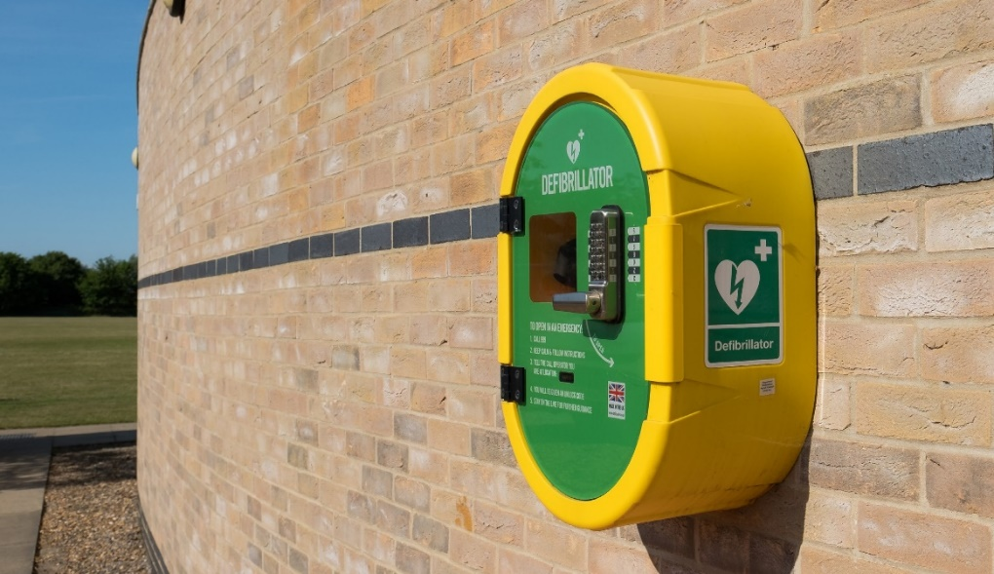**Objectives**

* Identify risks to the community and relevant response actions
* Support vulnerable citizens in the community
* Identify resources in the community available to assist during an emergency
* Provide key contact details for the Community Response Team, Key Community Resources, the Emergency Services and Local Authorities
* Assist Dumfries & Galloway Council’s Ward Officers with situational updates relevant to your Community

**Scenario Assessments**

When assessing the risks in the community the likelihood and the impact of the event should be considered. Many of the risks will be planned for at a National / Regional / Council level. Therefore, the risk assessments should consider how the community could respond to ensure the community’s safety / wellbeing. **Note that these responses if appropriate should only take place in the absence of outside support or with express consent of the emergency services.**

The table below has some suggested impacts to consider and some possible actions. There is a high possibility that communities could be faced with a combination of these and this should be taken into account when assessing the risk.

|  |  |  |
| --- | --- | --- |
| **Risk / Hazard** | **Suggested Impacts on the Community/ Vulnerability** | **Possible Actions**  **(If outside help not available)** |
| Sustained Power Failure | Loss of heating/ cooling Loss of refrigeration Loss of light  Loss of emergency communications  Loss of pumped water/ sewerage | Emergency reception centre Distribution of heating  Distribution of warm meals/ cooking facilities Distribution of lighting  Relocation/Evacuation |
| Sustained Water Failure | Loss of drinking water Loss of water for animals  Loss of water for washing/ cleaning | Emergency reception centre Distribution of drinking water  Relocation/Evacuation |
| Heavy Snow/ Freezing | Loss of access Food shortages  Loss of drinking water | Emergency reception centre Relocation/Evacuation |
| Flooding | Loss of access  Loss of emergency communications | Emergency reception centre  Relocation/Evacuation |
| Sustained Gas Failure | Loss of heating | Emergency reception centre  Relocation/Evacuation |
| Gales/Gusting Winds | Tree falls causing power outages/access problems  Damage to buildings | Work Teams Relocation/Evacuation |
| Fuel Shortages | Loss of transport/ access Food shortages | Emergency reception centre Distribution of heating  Distribution of warm meals/ cooking facilities  Relocation/Evacuation |
| Landslide | Loss of access  Food shortages | Reception Centre  Evacuation |

**The Community Response Team Co-ordinator should:**

* Oversee the completion and updating of the Community Response Plan.
* Ensure that the plan is regularly reviewed and updated (including contact details).
* Report annually to the Community detailing if the plan has been activated and highlighting any changes to the CRT members.
* Act as a focal point for the community in the response to an emergency.
* Act as the main contact point for the Council’s local Ward Officers and ensure that two-way communication is maintained.
* Ensure that the appropriate authorities and individuals are notified.
* Communicate important messages to and from the community.
* Activate resources as required.

Tasks should be delegated to team members as appropriate. The Co-ordinator should ensure that all team members are engaged in the planning and response processes.

**All members of the Community Response Team should:**

* Reside in the community.
* Have good local knowledge.
* Be able to activate the support of the community and speak on behalf of the community.
* Ensure that the vulnerable are provided with additional assurance during an emergency.
* Ensure that communications are maintained within the community and the Council’s Ward Officers / Resilience Team.
* Ensure that confidentiality is maintained where necessary.
* Maintain his/her own action log in the event of an emergency.
* Create a Household Emergency Lifesaving Pack (H.E.L.P) containing the plan and any appropriate clothing / equipment which may be required.
* Have sufficient knowledge of the plan to deputise as co-ordinator when required.

The Deputy and other team members should support the Co-ordinator in carrying out their role.

**Plan Maintenance**

The CRT should meet to discuss the community’s resilience on a regular (suggest quarterly) basis.

CRTs should review their plan on a regular basis throughout the year to ensure the information remains up to date and ready for implementation. Consideration should be given to a review in August and May each year.

When issuing updated pages of the plan it is important to ensure that all copies of the plan are updated to help ensure that all the plans are correctly updated/ and (the removed pages are returned from those on the distribution list as this will help ensure that all the plans are correctly updated.

**ANNEXES**

**Annex A**

**Emergency Action Check List**

This procedure details the call out order, communicating of information to the community and logging of actions.

|  |  |  |
| --- | --- | --- |
| **Action** |  | **Complete** |
| 1 | Dial 999 and ensure the emergency services are aware of the emergency and follow any advice given |  |
| 2 | Contact and inform your Council – on 030 33 33 3000  (Ask that the Ward Officer & Resilience Team are informed) |  |
| 3 | Contact utilities as appropriate (Elec, Gas, Water, Phone) – **Don’t Delay If You Smell Gas** |  |
| 4 | Begin recording details on the Log Sheet including:   * Any decisions you have made and why * Actions taken * Who you spoke to and what you said (Including contact numbers) * Any information received |  |
| 5 | Contact other members of the Community Response Team and members of the community that need to be alerted:   * Households affected * The Community Council / Councillor (see Annex ??) * Volunteers and key holders as appropriate |  |
| 6 | If necessary, call a community meeting but ensure the venue is safe and people can get there safely or alternatively convene an online/conference call. |  |
| 7 | Make sure you take notes and record actions from the meeting. If a decision is reached to activate the Emergency Plan, ensure that steps 1 – 4 above are carried out. |  |
| 8 | Provide Dumfries & Galloway Council’s Ward Officers with situational updates relevant to your Community.  (Updates will then be given to Safety & Resilience Team) |  |

**Under no circumstances should you put yourself or others at risk to fulfil these tasks.**

**Annex B**

**Logging Sheet**

It is important to record all information during an emergency. Completing a logging sheet is an easy way to ensure information is not lost. It can also help support / justify any decisions made or actions taken.

|  |  |  |  |
| --- | --- | --- | --- |
| **Date** | **Time** | **Information / Decision / Action** | **Initials** |
|  |  |  |  |
|  |  |  |  |
|  |  |  |  |
|  |  |  |  |
|  |  |  |  |
|  |  |  |  |
|  |  |  |  |
|  |  |  |  |
|  |  |  |  |

**Annex C**

**Maps of the community**

Maps of the community should be attached highlighting any key buildings and major hazards. Consider using “what 3 words” for pinpointing accurate locations https://what3words.com/about-us/

Give consideration to using OS Grid Reference Maps

**Please insert map**

**Key Buildings**

|  |  |  |  |
| --- | --- | --- | --- |
| **Building** | **Location**  **“what 3 words”** | **Potential use in an Emergency** | **Contact / Key holder** |
| **Example:** Church Hall | **Example:**  Sampleton village | **Example:** Rest Centre/safe place | **Example:** Church warden’s name & contact number |
|  |  |  |  |
|  |  |  |  |
|  |  |  |  |
|  |  |  |  |
|  |  |  |  |
|  |  |  |  |
|  |  |  |  |
|  |  |  |  |
|  |  |  |  |
|  |  |  |  |
|  |  |  |  |
|  |  |  |  |
|  |  |  |  |
|  |  |  |  |
|  |  |  |  |
|  |  |  |  |
|  |  |  |  |
|  |  |  |  |
|  |  |  |  |

**Annex D**

**Restricted Information (this information will not be shared)**

|  |  |  |  |
| --- | --- | --- | --- |
| **Service / Name Telephone Number Website Additional Information** | | | |
|  |  |  |  |
|  |  |  |  |
|  |  |  |  |
|  |  |  |  |
|  |  |  |  |
|  |  |  |  |
|  |  |  |  |
|  |  |  |  |
|  |  |  |  |
|  |  |  |  |
|  |  |  |  |
|  |  |  |  |
|  |  |  |  |
|  |  |  |  |
|  |  |  |  |

**Annex E**

**Insurance Information**

If your Community Resilience Team is affiliated to your Community Council, then Community Resilience Insurance is already in place for you. Only those details contained within your resilience plan are covered, therefore keeping your plan up to date is important. It is further important to ensure the updates are conveyed to your Ward Officer prior to carrying out any new tasks. We want you to be safe in supporting those in your community.

If you are an independent group NOT affiliated with a Community Council, then we recommend obtaining resilience insurance. This will ensure you are covered whilst supporting your community. Please contact your Ward Officer to discuss where to obtain insurance and what support maybe available to you in securing this insurance.

Community Resilience Insurance does not cover the use of your own vehicle or use of your home. However, depending on the emergency, there maybe opportunities to assist with this. Speak with your Ward Officer.

**Insert Policy Here (summary page)**

|  |
| --- |
|  |

**Annex F**

**GDPR**

Dumfries and Galloway Council wants to ensure that by working in partnership with other statutory agencies and voluntary sector organisations that we are able to maximise our collective ability to respond and support the needs of our most vulnerable citizens during the COVID-19 pandemic.

The following advice has been prepared to assist community groups and resilience teams to take appropriate measures should there be a requirement for you to collect and store personal data during an emergency.

Ready Scotland – Scottish Government Advice for Community Groups

Ready Scotland has prepared guidance with established community resilience teams in mind, but this can also be used by any group of people who want to help in their community during an emergency in a way that is safe, sustainable and protects our most vulnerable citizens. The guidance document includes useful information on protecting yourself, as a volunteer, and those you want to help; communicating; supporting vulnerable citizens; an integrated response and requesting help from volunteers.

If your group is helping vulnerable residents, then please follow all the relevant Government advice and consider how you can do this in a way which is safe for those that you are helping and also for yourself and your team of volunteers.

For example:

* Phone - Exchange phone numbers with your neighbours and keep in touch regularly by text or telephone call.
* Deliveries - If your group is doing essential deliveries of food or medicine, ensure you follow national guidance.
* Safety – Vulnerable residents may find themselves vulnerable to scams. Where they exist, please considering signing up to Neighbourhood Watch Scotland alerts to find out about scams in your local area so that you can share this information across your community networks.

**Considerations when Handling Sensitive Data**

We would recommend that you consider a leaflet drop to households in your community which has useful contact numbers/emails, including those for members of your resilience team/community group

The responsibility then lies with individuals to make contact direct with their local resilience team or any other relevant organisation and ask for support and negates the need for local resilience teams to hold any personal or sensitive data unnecessarily.

If required, we strongly recommend that you keep to a minimum, any data that you may need to support people and that any information you do hold is held securely. This information could be captured at the point of contact to ensure you can fulfil the support requested (name/address/telephone number/email) and by no other means. No medical or further personal details should be captured or stored.

All information should be captured and stored in line with General Data Protection Regulations (GDPR) Legislation and any guidance provided by the Information Commissioners Office (ICO) and thereafter, disposed of in accordance with appropriate regulation once the COVID-19 response has concluded.

**Disclaimer**

The following key points should be borne in mind when completing this template:

* This document neither implies nor intends any formal role for villages, towns or any part of the community (collectively called the ‘community) in the response to, or recovery from, emergencies.
* There is no role implied for the community in support of the emergency services in their response to incidents.
* The completion of the document template, in part or in full, is entirely voluntary and is the responsibility of the local community.
* While the local community has no formal role, there is widespread recognition of the value of planning from the lowest practicable level upwards to help cope with potential local emergencies.
* The need to complete any part of the template, or the requirement to include other relevant information, will depend on the nature and composition of the community and the likely hazards.
* Dumfries & Galloway Council Resilience & Community Safety or Ward Officers may provide advice and assistance where requested, and where relevant, to support the completion of the template.
* Dumfries & Galloway Council accept no responsibility for the content of the completed template.
* The local community is encouraged to submit a copy of the completed template with the Safety and Resilience Unit.
* Significant amendments to the completed template, especially changes in contact details, should be passed to your local Ward Officer and / or the Council’s Resilience & Community Safety Team.

