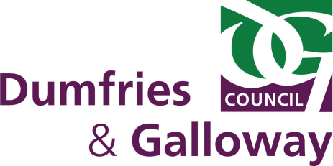
REQUIREMENTS SINCE FEBRUARY 2017
The New National Standard now applies and is based only on the structural requirements of the Food Hygiene Regulations.
- Eligibility for inspections is now restricted to Food Businesses registered with Dumfries & Galloway Council

DUMFRIES & GALLOWAY COUNCIL
CIVIC GOVERNMENT (SCOTLAND) ACT 1982
APPLICATION FOR CERTIFICATE OF COMPLIANCE/RENEWAL OF CERTIFICATE OF COMPLIANCE
(delete as appropriate)

PLEASE COMPLETE IN BLOCK CAPITALS:
1. SURNAME: | FIRST NAME(S):
2. HOME ADDRESS: | PHONE NO:
3. DATE OF BIRTH: | AGE:
4. INDICATE IF SELF-EMPLOYED – YES / NO | E-MAIL:
ADDITIONAL DETAILS TO BE COMPLETED IF APPLICATION IS BEING MADE ON BEHALF OF A COMPANY OR BUSINESS.
NOTE: CERTIFICATE WILL BE ISSUED IN THE NAME OF THE COMPANY OR BUSINESS
5. COMPANY OR BUSINESS NAME: | TELEPHONE NO:
6. ADDRESS OR REGISTERED OFFICE ADDRESS:
7. TYPE OF FOOD TO BE SOLD:
8. TYPE OF VEHICLE/KIOSK/MOVEABLE STALL (DESCRIPTION, MAKE REG NO:
AND MODEL): (if applicable)

9. ADDRESS OF SITE WHERE UNIT IS HOUSED OVERNIGHT:
10. TRADING ROUTE/PITCH:

SIGNATURE OF APPLICANT: ..………………………………………...................... DATE: ……………………………………
TO BE LODGED WITH ENVIRONMENTAL HEALTH, MILITIA HOUSE, ENGLISH STREET, DUMFRIES, DG1 2HR OR ENVIRONMENTALHEALTH@DUMGAL.GOV.UK TOGETHER WITH THE APPLICATION FEE/RENEWAL FEE OF £90.00 (NB THE LODGING FEE IS NON REFUNDABLE), MAKE PAYMENT BY CHEQUE OR TO PAY BY CREDIT/DEBIT CARD CALL US ON 030 33 33 33000 NOT LATER THAN 28 DAYS BEFORE THE CERTIFICATE IS REQUIRED. Additional copies - £45.00 each.
Note: CERTIFICATE IS VALID FOR 3 YEARS (April 2024)

