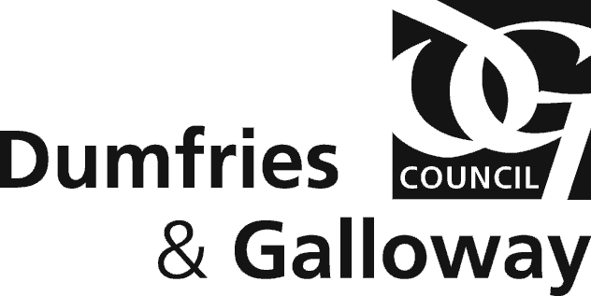

DUMFRIES AND GALLOWAY COUNCIL

EDUCATION SUPPORT SERVICES

APPLICATION FOR TRANSPORT – NON ENTITLED PUPILS SESSION 2024 - 2025

PUPIL NAME DATE OF BIRTH
ADDRESS

POST CODE TEL NO. _________________________________________
SCHOOL ____________________________________________ STAGE/YEAR SESSION 24-25 ___________
NAME OF ANY TRANSPORT ENTITLED SIBLING(S) OR ENTITLED CHILD(REN) WHO LIVE AT THE SAME ADDRESS
NAME _________________________________________ DOB_____________________________________
NAME _________________________________________ DOB_____________________________________
PARENT/GUARDIAN TITLE SIGNED
PRINT NAME DATE
EMAIL ADDRESS _________________________________________________________________________

Order of priority for non entitled pupils:-
- pupils who have an entitled sibling travelling
- pupils living in the catchment area living furthest from the school
- pupils living outwith the school catchment area living nearest to school
- pupils living outwith this authority area living nearest to school

This application only applies to School Session 2024/25. Parents should also note that transport for non entitled pupils can be withdrawn at any time should spaces be required for entitled pupils or if the capacity or route of a vehicle is changed. Non entitled pupils will not be removed from transport to allow other non-entitled pupils to travel.

Please note all completed applications must be returned to the school your child/ren will be attending in session 2024/25 by Friday 24 May 2024, school office will email them to NEPs@dumgal.gov.uk. A decision on your application will be issued no later than 13 September 2024. We are unable to provide an earlier decision on non-entitled spaces until all pupils have returned and the final uptake of entitled spaces has been fully confirmed with schools/operators.

For information regarding School Transport, please visit the Council’s website on: http://www.dumgal.gov.uk/
Please note that, in order to progress your application, the details supplied by you will be securely shared. For information on how the Council uses personal data, and to know more about your information rights including who to contact if you have a concern, please follow this link: http://www.dumgal.gov.uk/article/15129/Data-protection”

